# ****Phase 1: Problem Understanding & Industry Analysis****

## ****Problem Statement: Internal Helpdesk CRM****

**Prepared by:** **MACHAPATHRI VAMSHI**

### ****Requirement Gathering****

**Core Functionality:**  
Employees should be able to raise IT support tickets for issues such as password resets, software installation, or hardware problems. Tickets should automatically get assigned to the right IT support staff based on category, and the status should be tracked until resolution.

**Reporting & KPIs:**  
The system should measure average resolution time, ticket volume per category per month, and percentage of tickets resolved within SLA timelines.

**Automation:**  
Notifications should be sent to employees when tickets are created, updated, or resolved. Escalations should occur automatically if SLA timelines are breached.

### ****Stakeholder Analysis****

* **Employees:** Need a simple way to raise tickets and get updates quickly.
* **IT Support Team:** Need an organized queue of tickets to work on and update status easily.
* **IT Manager:** Needs dashboards and reports to monitor SLA performance and team workload.
* **Management:** Wants visibility into major recurring issues to take preventive actions.

### ****Business Process Mapping****

**Step 1:** Employee logs in and submits a ticket.  
**Step 2:** System auto-assigns ticket to appropriate support staff based on category.  
**Step 3:** Support staff works on the issue and updates ticket status.  
**Step 4:** Ticket is marked closed once resolved, and notification is sent to employee.  
**Step 5:** Resolution time and ticket data are captured for reports.

**Simple Process Flow Diagram (describe or draw):**

[Submit Ticket] → [Auto Assign] → [Work on Ticket] → [Close Ticket] → [Report Metrics]

### ****Industry-Specific Use Case Analysis****

An internal helpdesk CRM is critical for any corporate environment to ensure smooth IT operations. It helps reduce downtime, ensures SLA compliance, and improves employee satisfaction. For cybersecurity, it tracks security-related tickets like MFA issues or phishing reports, enabling faster incident response.

### ****AppExchange Exploration****

Explore ITSM and helpdesk apps on AppExchange such as **Service Cloud**, **Spoke Desk**, or **Milestones PM** to understand best practices in case management, escalation rules, and SLA tracking. These apps can provide inspiration for dashboards, reports, and automation flows.

# **Phase 2: Org Setup & Configuration**

# 1. Project Goal

Prepare Salesforce org with users, roles, profiles, permission sets, sharing settings, and email templates in preparation for building the Helpdesk Ticket object.

### Step 1: Log in to Salesforce Org

* Go to [https://login.salesforce.com](https://login.salesforce.com" \t "_new)
* Enter username and password
* Click **Log In**

## Step 2: Set Company Information

1. Setup → Quick Find → **Company Information** → Click
2. Verify/update:

* Company Name
* Primary Contact
* Default Locale: English (India)
* Default Time Zone: Asia/Kolkata

1. Click **Edit** → update → **Save**

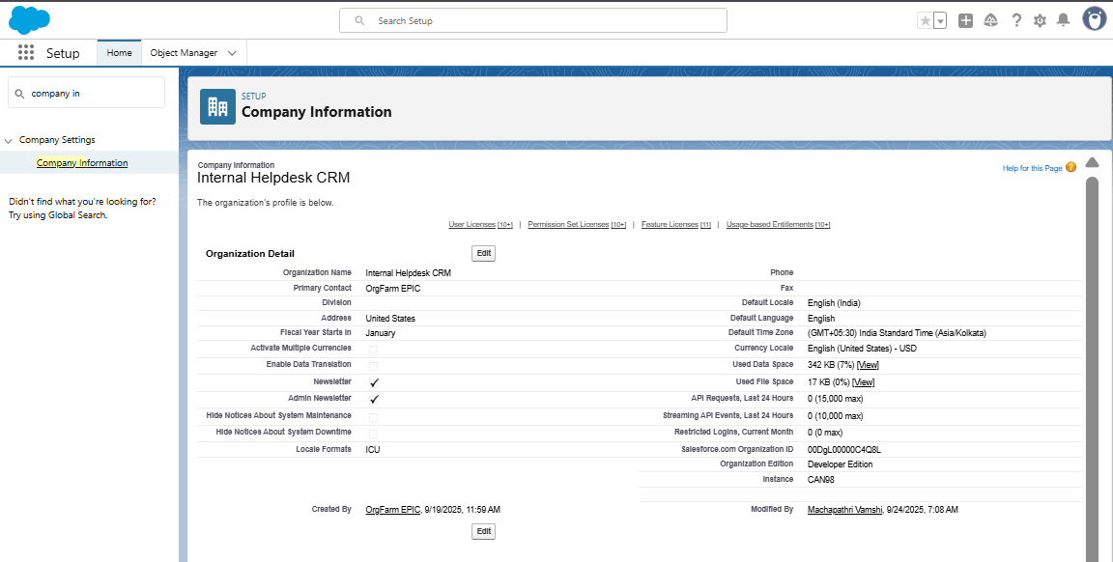

## Step 3: Define Business Hours

1. Setup → Quick Find → **Business Hours** → Click
2. Click **New Business Hours**:

Name: IT Support Hours

Default: yes

Time Zone: Asia/Kolkata

Open: 09:00 → Close: 06:00 (Mon-Fri)

1. Click Save

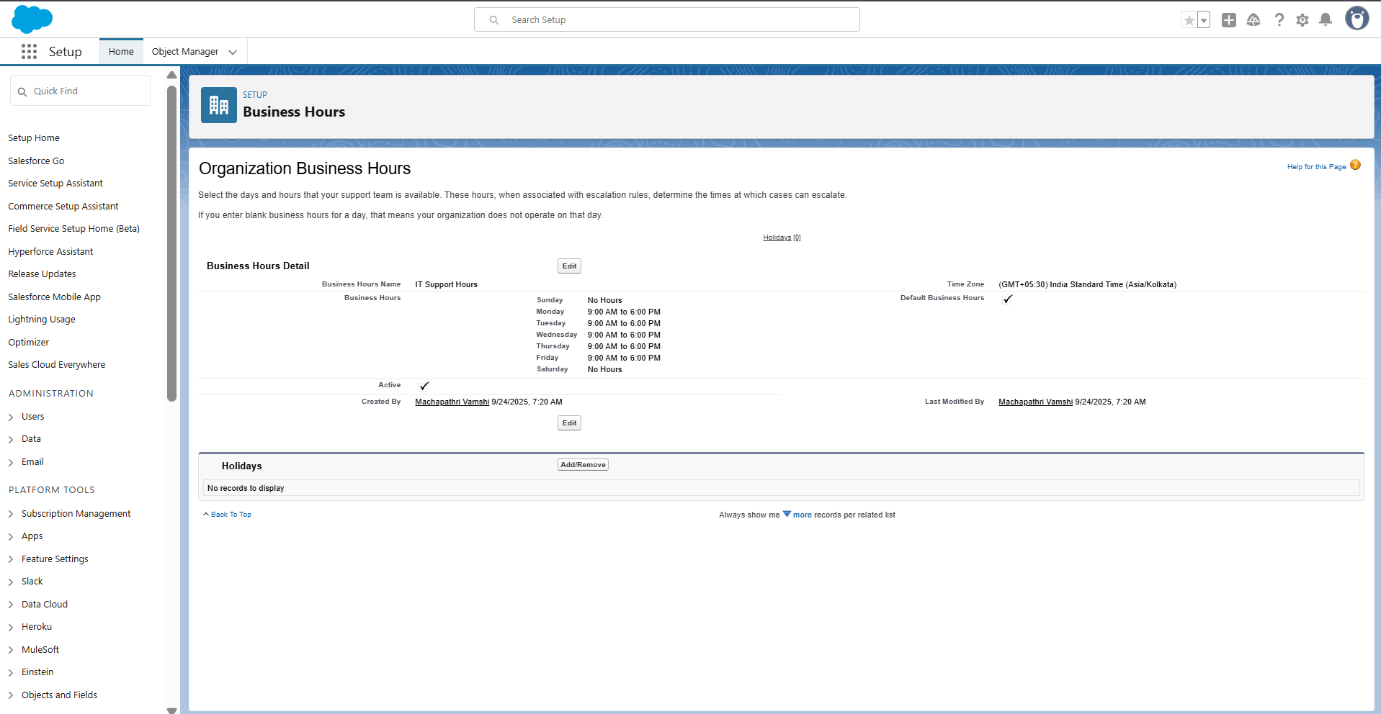

## Step 4: Add Holidays

1. Setup → Quick Find → **Holidays** → Click
2. Click **New Holiday**:

* Holiday Name: Republic Day
* Date: 26-Jan

1. Click Save
2. Click **Add Business Hours** → add IT Support Hours

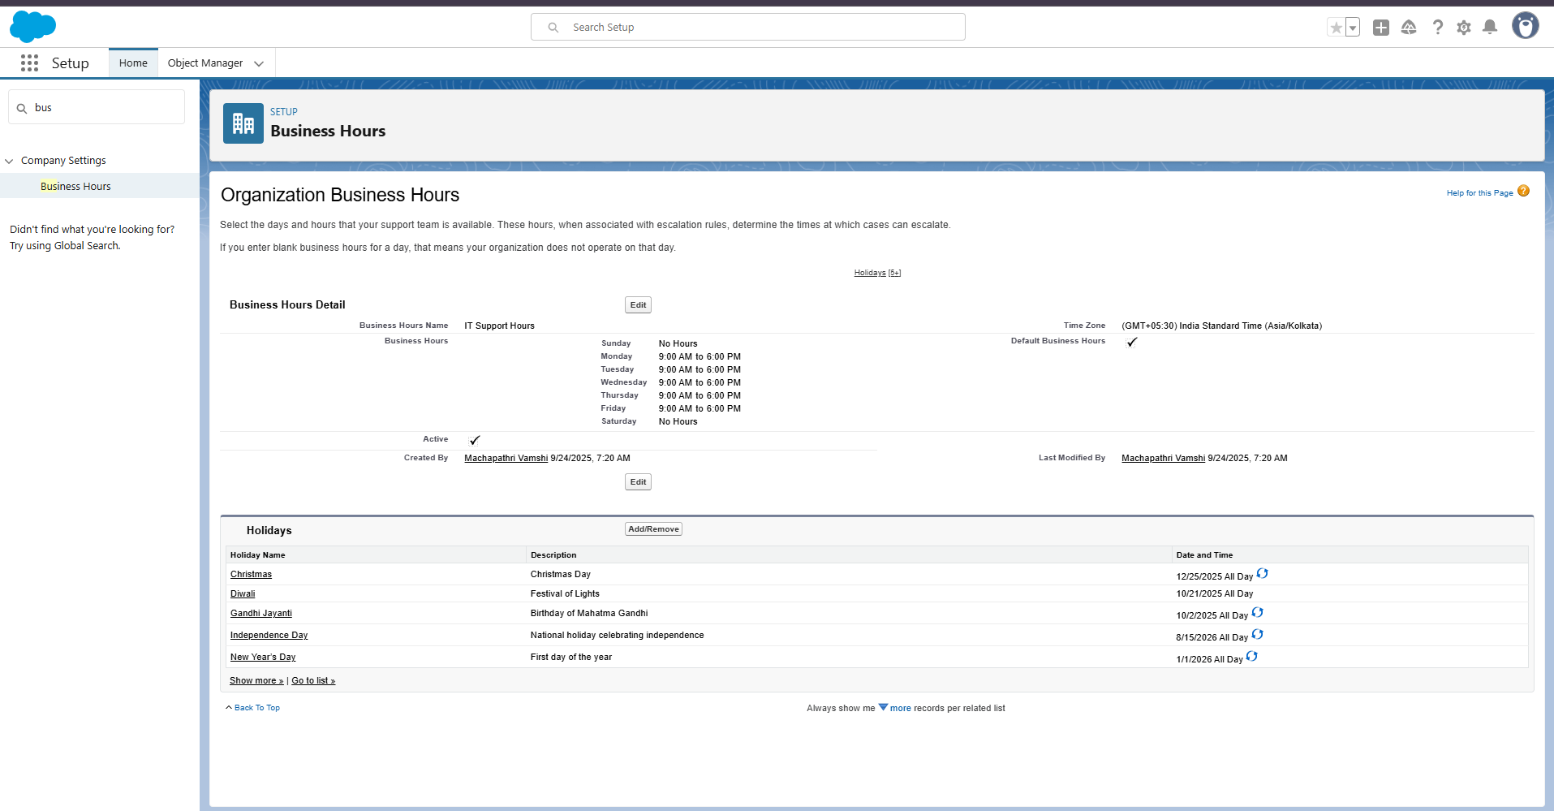

## Step 5: Create Role Hierarchy

1. Setup → Quick Find → Roles → Click Set Up Roles
2. Click Expand All
3. Add roles:

* CEO
* IT Manager
* IT Support
* Employee

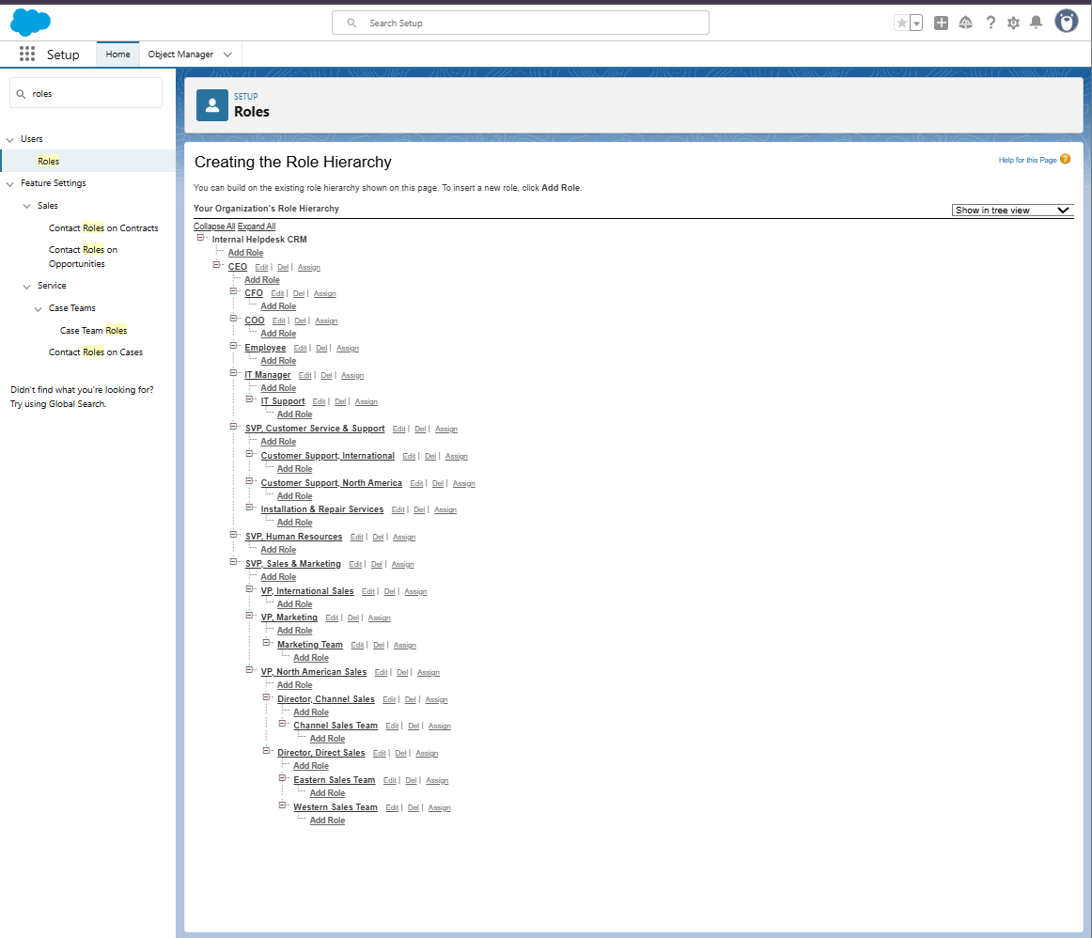

## Step 6: Create Users

1. Setup → Quick Find → Users → Click New User
2. Employee User:

* First Name: Employee | Last Name: Test
* Alias: EMP
* Email: working email
* Username: unique (employee.test@internalhelpdesk.com)
* Profile: Standard User
* Role: Employee → Save

1. IT Support User:

* Profile: System Administrator
* Role: IT Support → Save

1. (Optional) IT Manager user with role IT Manager

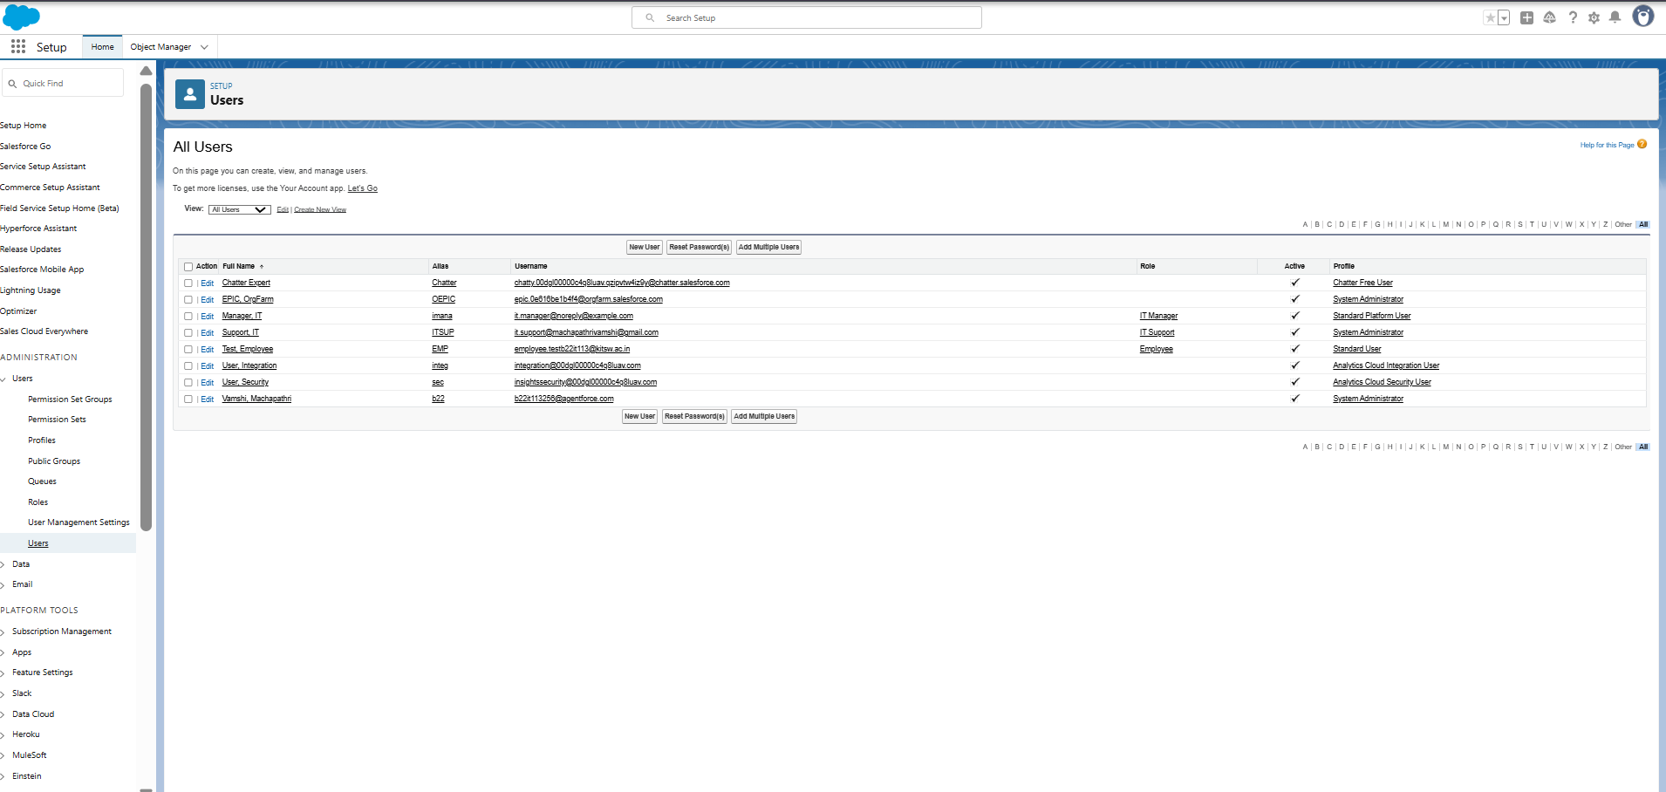

## Step 7: Create Permission Set

1. Setup → Quick Find → Permission Sets → Click New
2. Label: Helpdesk Access
3. API Name: auto-fills
4. Click Save
5. Assign object permissions after Phase 3

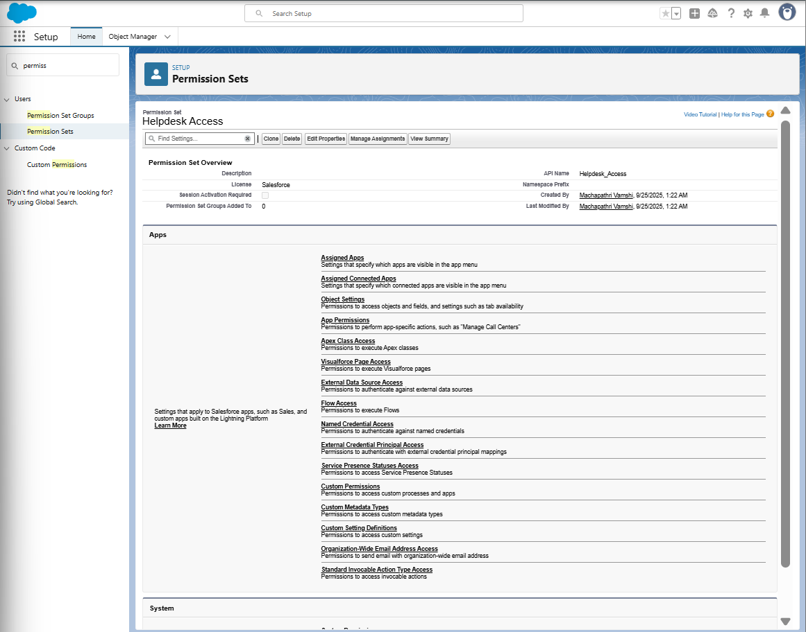

## Step 8: Prepare Org-Wide Defaults (OWD)

1. Setup → Quick Find → Sharing Settings → Click
2. Click Edit
3. Note: Helpdesk Ticket object will be Private after Phase 3
4. Click Save

## Step 9: Create Public Group

1. Setup → Quick Find → Public Groups → Click New
2. Label: IT Support Group
3. Add IT Support User → Save

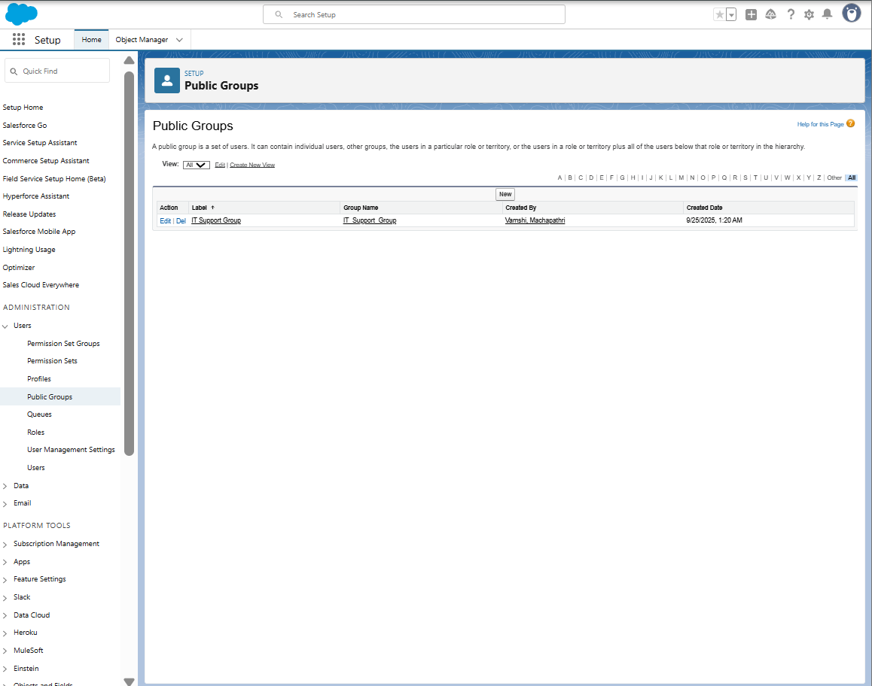

## Step 10: Enable Admin Login Access

1. Setup → Quick Find → Login Access Policies → Click
2. Check Administrators Can Log in as Any User → Save

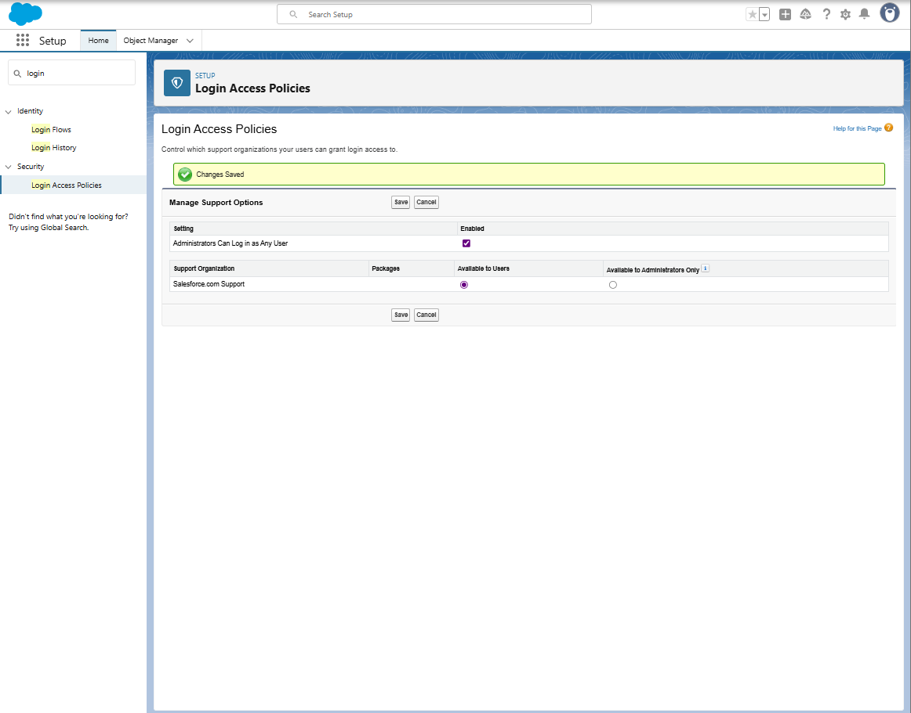

## Step 11: Create Email Templates

1. Setup → Quick Find → Email Templates → Click
2. New Email Template (Classic):

* Folder: Unfiled Public Email Templates
* Available For Use: ✔️
* Template Name: Ticket Submitted
* Subject: Your Helpdesk Ticket {!Helpdesk\_Ticket\_\_c.Name} has been submitted
* Text/HTML Body Example:

Hello {!Helpdesk\_Ticket\_\_c.Requester\_\_c},

Your ticket "{!Helpdesk\_Ticket\_\_c.Description\_\_c}" has been created successfully.

Ticket Number: {!Helpdesk\_Ticket\_\_c.Name}

Status: {!Helpdesk\_Ticket\_\_c.Status\_\_c}

Our IT Support team will review and get back to you soon.

Thanks,

IT Helpdesk Team

1. Save ✅
2. Repeat for Ticket Updated and Ticket Resolved
3. 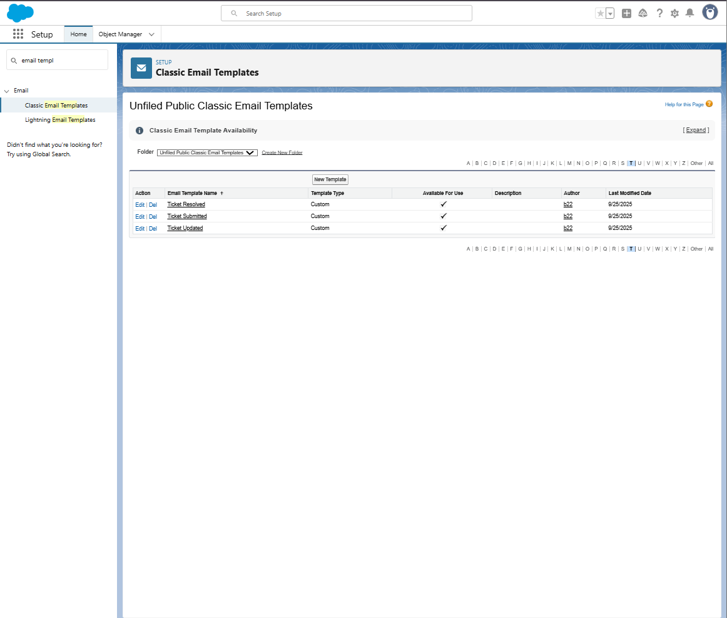

## 3. Final Confirmation Checklist

* Log in to Salesforce Org
* Set Company Information
* Define Business Hours
* Add Holidays
* Create Role Hierarchy
* Create Users
* Create Permission Set
* Prepare Org-Wide Defaults
* Create Public Group
* Enable Admin Login Access
* Create Email Templates (Ticket Submitted, Updated, Resolved)
* Assign object permissions after Phase 3

# ****Phase 3: Data Modeling & Relationships**** **Objective**:**** Build the Helpdesk Ticket object with fields, layouts, and relationships to manage internal IT tickets.

## ****Step 1: Create Custom Object – Helpdesk Ticket****

**Purpose:** Create a custom object to store all helpdesk tickets.

**Steps:**

1. Go to **Setup ⚙️ → Object Manager → Create → Custom Object**.
2. Fill details:

* **Label:** Helpdesk Ticket
* **Plural Label:** Helpdesk Tickets
* **Object Name:** Helpdesk\_Ticket
* **Record Name:** Auto Number → Format: HT-{0000}
* **Optional:** Description for documentation

1. Click **Save** ✅

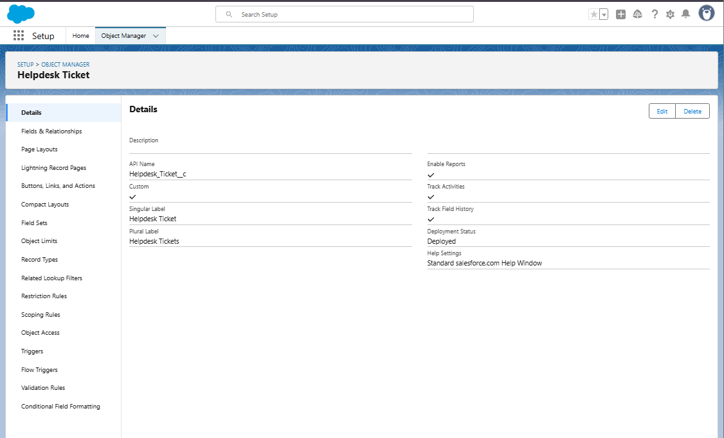

## ****Step 2: Add Custom Fields****

**Purpose:** Capture ticket information.

| **Field Label** | **Data Type** | **Details** | **Required** |
| --- | --- | --- | --- |
| Ticket Number | Auto Number | Format: HT-{0000} | checked |
| Description | Text Area | 255 characters | checked |
| Requester | Text | 50 characters | checked |
| Assigned To | Lookup (User) | – | Optional |
| Status | Picklist | New, In Progress, On Hold, Resolved, Closed | checked |
| Priority | Picklist | Low, Medium, High, Urgent | checked |
| Category | Picklist | Hardware, Software, Network, Other | Optional |
| Due Date | Date | – | Optional |
| Resolution Notes | Long Text Area | 500 characters | Optional |

**Steps to Create Fields:**

1. Object Manager → Helpdesk Ticket → **Fields & Relationships → New**.
2. Select **Data Type** → Next.
3. Fill **Field Details** → Next.
4. Set **Field-Level Security** → Next.
5. Add to **Page Layout** → Save.
6. Repeat for all fields.

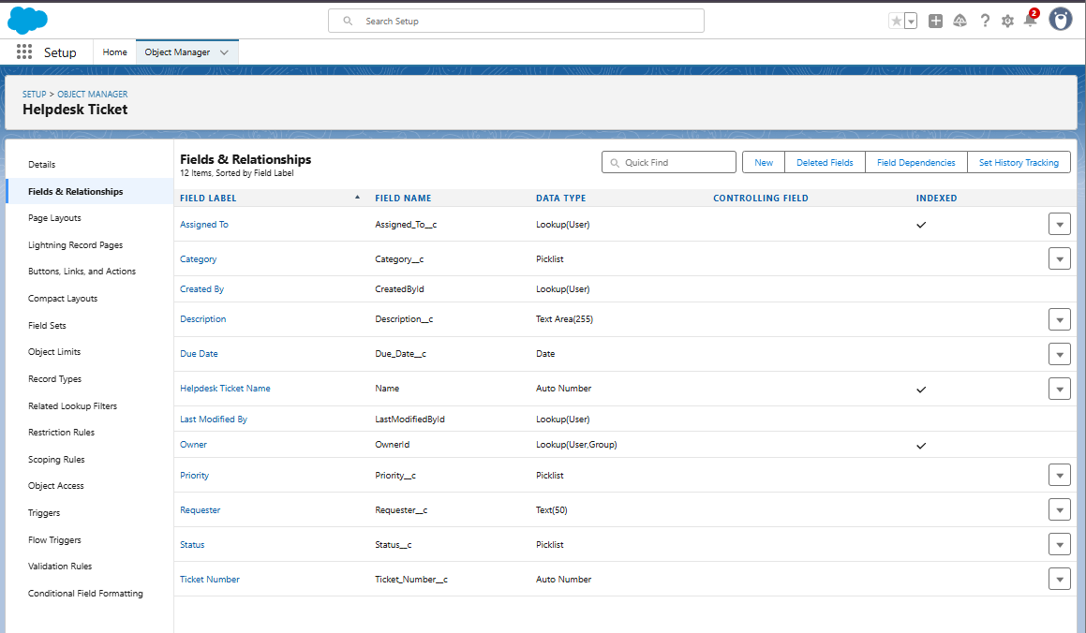

## Step 3: Configure Page Layout

Purpose: Organize fields, sections, and related lists on the record page.

## Steps:

1. Object Manager → Helpdesk Ticket → Page Layouts → Edit.
2. Organize sections:

* **Ticket Information**: Ticket Number, Description, Requester, Assigned To
* Details: Status, Priority, Category, Due Date
* Resolution: Resolution Notes
* System Information: Created By, Last Modified By, Owner

1. Configure Related Lists: Open Activities, Activity History
2. Use Highlights Panel for key fields: Ticket Number, Status, Priority, Assigned To
3. Save ✅

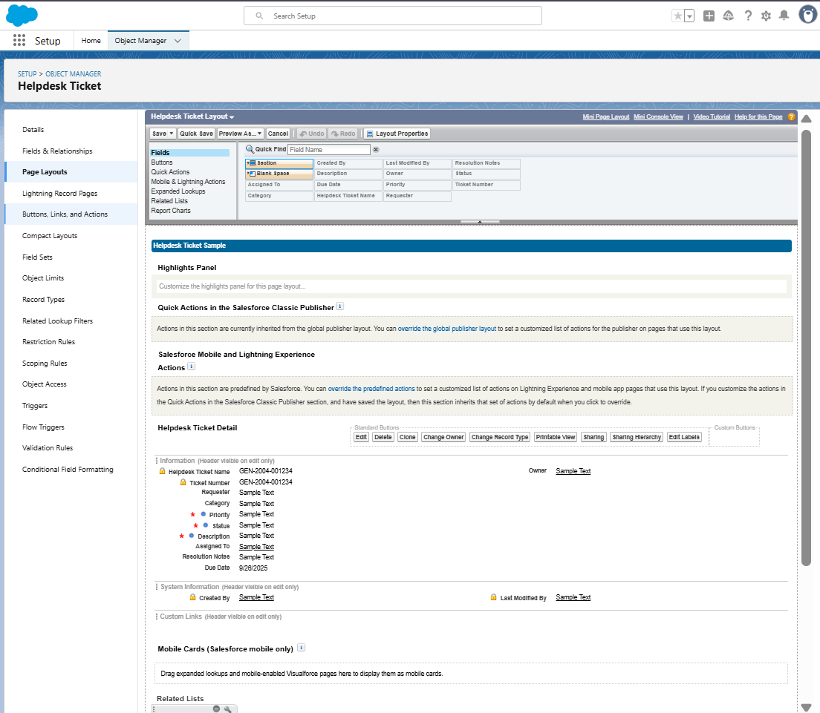

## Step 4: Enable Field History Tracking

Purpose: Track changes to critical fields.

Steps:

1. Object Manager → Helpdesk Ticket → Fields & Relationships → Set History Tracking.
2. Select fields: Assigned To, Description, Status, Priority, Category, Due Date, Resolution Notes
3. Enable Track old and new values → Save ✅
4. In Page Layout → Drag Helpdesk Ticket History related list → Save

## Step 5: Permission Set – Helpdesk Access

Purpose**:** Control object and field permissions for users.

## Steps:

1. Setup → Quick Find → **Permission Sets → Helpdesk Access**.
2. Click **Object Settings → Helpdesk Ticket → Edit**.
3. Grant: **Read, Create, Edit** (do not give Delete unless needed).
4. Click **Field Permissions** → adjust visibility for sensitive fields like Resolution Notes
5. Assign to users: **Manage Assignments → Add Assignments → Select Employee users → Assign**

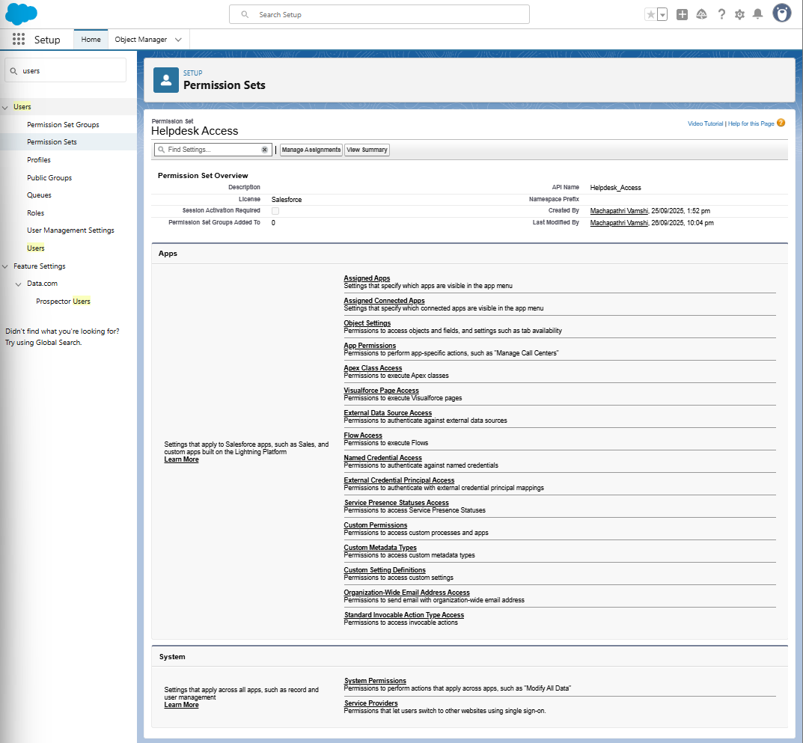

# Step 6: Org-Wide Defaults (OWD) — set Private

1. Setup → Quick Find → **Sharing Settings** → click.
2. Under **Organization-Wide Defaults**, find **Helpdesk Ticket** → set **Default Internal Access** = **Private**.
3. Click **Save**

## **Screenshot 2025-09-26 225021**

## ****Step 7: Test Object Access****

Purpose**:** Ensure correct access and functionality.

## Steps:

1. Log in as **Employee user** → Create ticket → check all fields
2. Log in as **IT Support user** → View/update tickets → verify access
3. Log in as **System Administrator** → Confirm full access

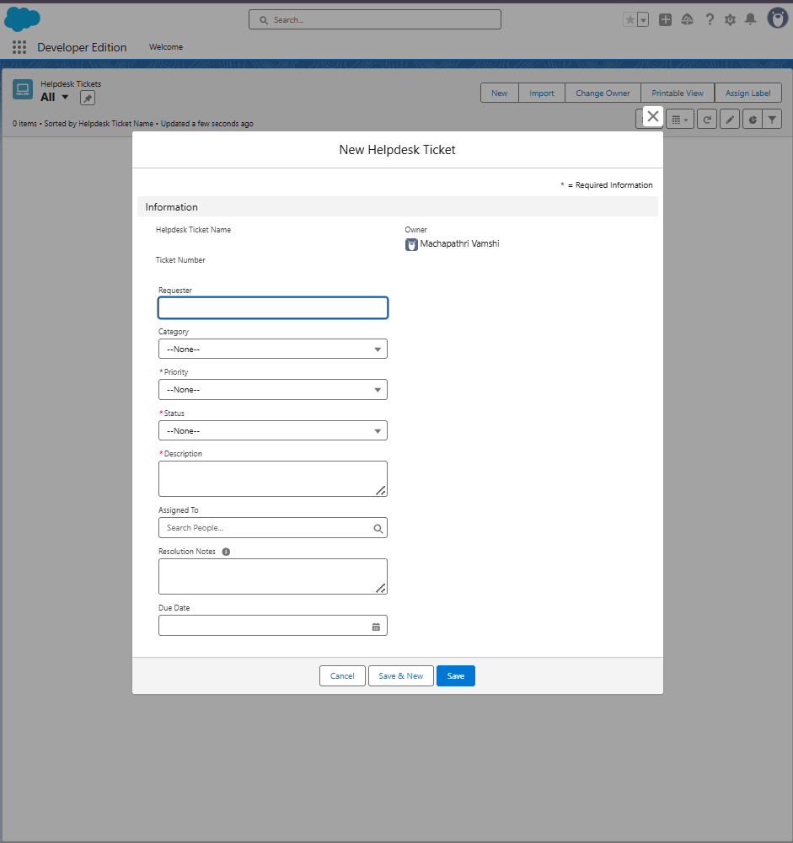

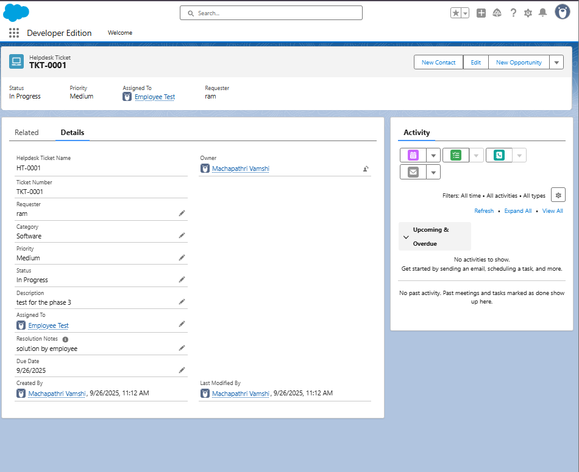

# Optional Advanced Features

# Step 8: Schema Builder

Purpose**:** Visualize objects, fields, and relationships.

## Steps:

1. Setup → Quick Find → **Schema Builder → Click**
2. Select objects: **Helpdesk Ticket, User, Role** (optional), related objects
3. Drag and drop to organize layout for better visualization
4. Take screenshots for documentation

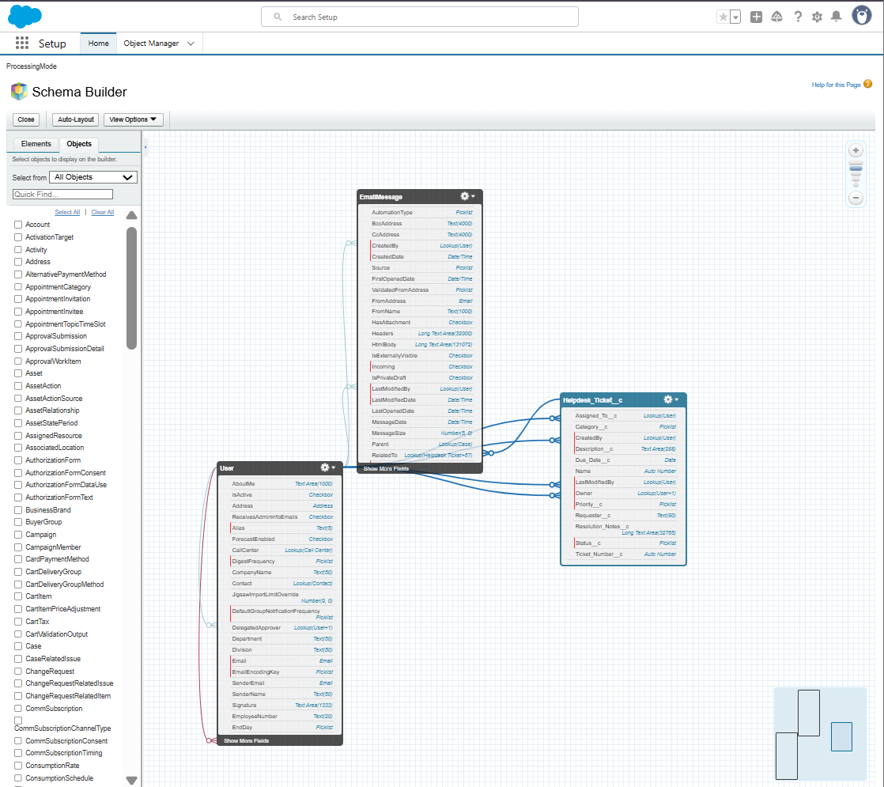

# Step 9: Junction Objects (Optional)

Purpose**:** Create many-to-many relationships.

## Steps:

1. Setup → Object Manager → Create → Custom Object → Name: Ticket-Asset Assignment
2. Record Name: Auto Number → TAA-0001 → Save
3. Create **Master-Detail Relationships**:

* Helpdesk Ticket → Save
* Asset → Save

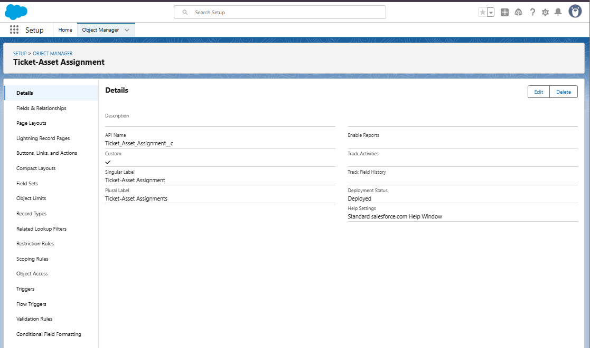

## Step 10: Validation Rule — require Resolution Notes when Status = Resolved

1. Object Manager → Helpdesk Ticket → **Validation Rules** → **New**.
2. Rule Label: Require\_Resolution\_Notes\_When\_Resolved
3. Formula (copy exactly):

AND(

ISPICKVAL(Status\_\_c, "Resolved"),

ISBLANK( Resolution\_Notes\_\_c )

)

1. Error Message: Please enter Resolution Notes before marking the ticket as Resolved.
2. Error Location: **Field** → choose Resolution Notes → Save.

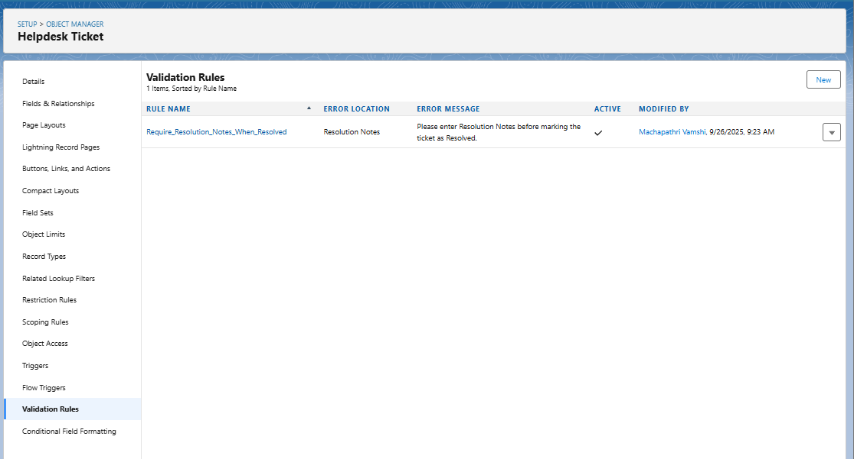

# ****Phase 3 Completion – Data Modeling & Relationships****

* Custom Object: **Helpdesk Ticket** created with Ticket Number (Auto Number).
* Custom Fields: Description, Requester, Assigned To, Status, Priority, Category, Due Date, Resolution Notes.
* Page Layouts: Configured with sections, highlights panel, and related lists.
* Field History Tracking: Enabled for key fields.
* Permission Set: **Helpdesk Access** created and assigned.
* Field-Level Security: Resolution Notes restricted for Employee users.
* Schema Builder: Used to visualize objects and relationships.
* Validation Rules: Configured (e.g., Due Date ≥ Today).
* Automation: Flows / Process Builder for ticket emails.
* Testing: Verified Employee, IT Support, and System Admin access.

# Phase 4: Process Automation (Admin)

## Objective

To automate Helpdesk Ticket operations such as email alerts, field updates, and validations using Salesforce automation tools — including Flows, Validation Rules, Process Builder, and Email Alerts.

## Step 1: Validation Rule

Goal: Ensure all required data is entered before saving records.

Example Rule – Due Date cannot be past:

1. Go to Setup → Object Manager → Helpdesk Ticket → Validation Rules → New.
2. Enter Rule Name: Validate\_Due\_Date.
3. Enter Error Condition Formula: Due\_Date\_\_c < TODAY()
4. Enter Error Message: “Due Date cannot be earlier than today.”
5. Location: Top of Page.
6. Click Save.



## Step 2: Create Record-Triggered Flow (Ticket Status Email Flow)

1. Setup → Quick Find → Flows → New Flow.
2. Choose Record-Triggered Flow.
3. Object: Helpdesk Ticket.
4. Trigger: A record is created or updated.
5. Optimize for: Actions and Related Records.
6. Click Done.

## Screenshot 2025-09-27 113537

## Step 3: Add Decision Element

Goal: Decide which email to send based on Status.

From Flow Builder → Add Decision → Label it 'Check Ticket Status'.

Outcomes:

|  |  |
| --- | --- |
| Outcome Name | Condition |
| Ticket Submitted | Status\_\_c Equals 'New' |
| Ticket Updated | Status\_\_c Equals 'In Progress' OR Status\_\_c Equals 'On Hold' |
| Ticket Resolved | Status\_\_c Equals 'Resolved' |

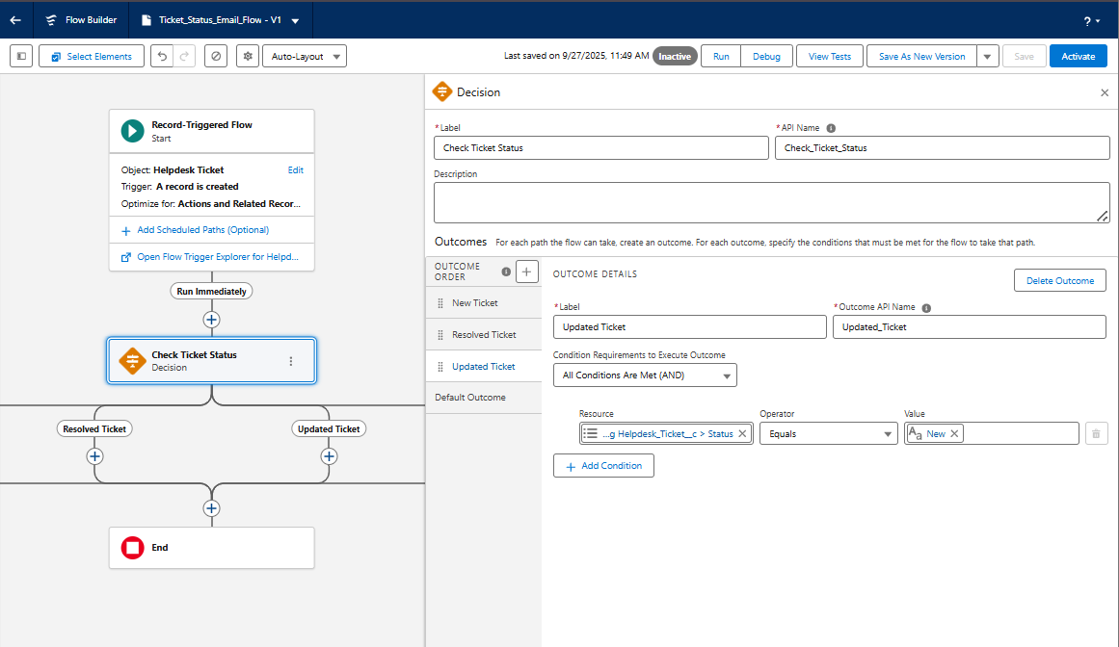

## Step 4: Create Email Templates

Go to Setup → Email Templates → New Email Template. Create 3 templates:

1. Ticket Submitted  
2. Ticket Updated  
3. Ticket Resolved

Use merge fields like:

Hello {!Helpdesk\_Ticket\_\_c.Requester\_User\_\_c.Name},  
  
Your ticket "{!Helpdesk\_Ticket\_\_c.Description\_\_c}" has been updated.  
  
Status: {!Helpdesk\_Ticket\_\_c.Status\_\_c}

## Step 5: Configure Email Actions

In Flow → after Decision Node → Add Action → Send Email (Core Action)

Example: Send Ticket Submitted Email

|  |  |
| --- | --- |
| Field | Value |
| Label | Send Ticket Submitted Email |
| Recipient ID | Triggering Record → Requester\_User\_\_c |
| Sender Type | Current User |
| Email Template ID | Ticket Submitted |
| Related Record ID | $Record.Id |
| Log Email on Send | Checked |

Repeat for Ticket Updated and Ticket Resolved emails.

## Step 6: Save and Activate Flow

Click Save → Name Flow 'Ticket\_Status\_Email\_Flow' → Activate.

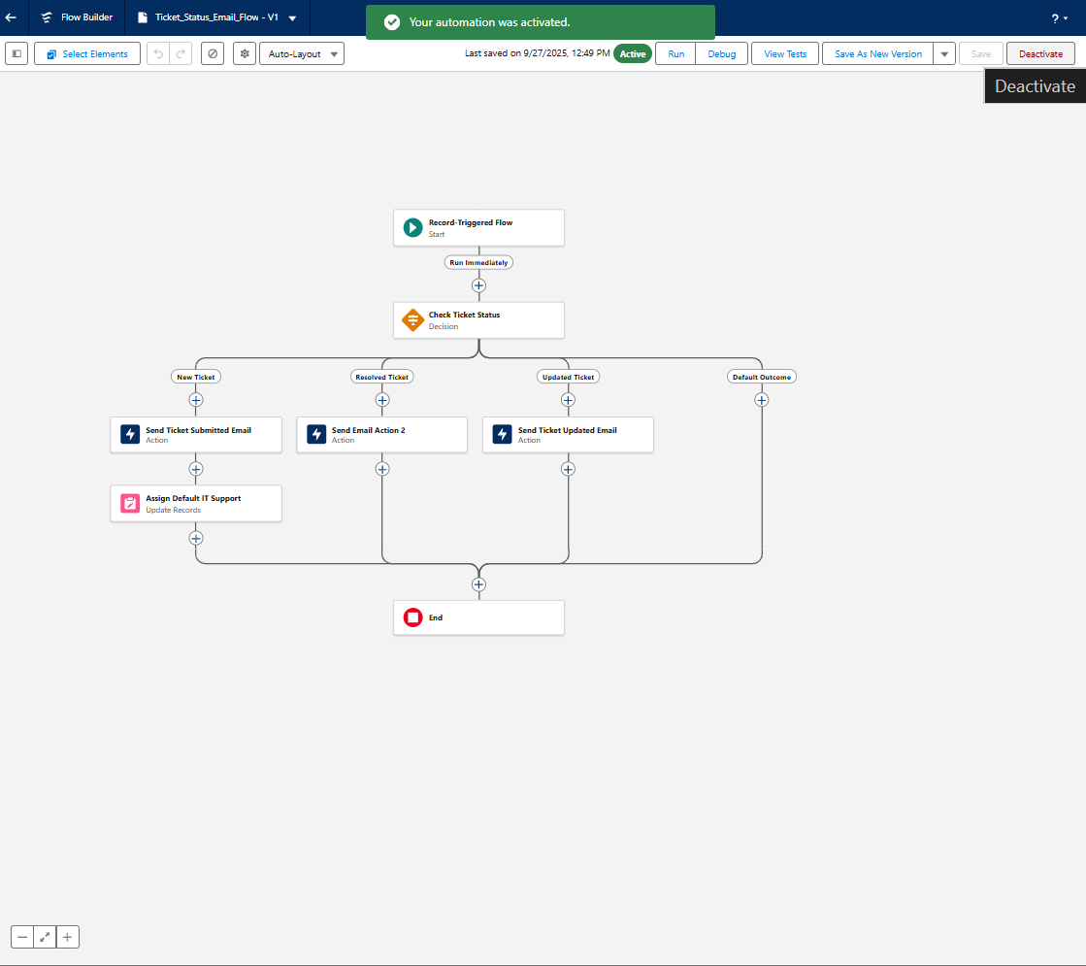

## Step 7: Testing the Automation

1. Log in as Employee → Create a ticket with Status = New → Check email inbox.
2. Update ticket to In Progress → Check Ticket Updated email.
3. Update ticket to Resolved → Check Ticket Resolved email.

## IMG_256Step 8: Optional Automations

Workflow Rule: Send alerts for high priority tickets.

Process Builder: Automate field updates or task creation.

Custom Notifications: Push alerts to IT Support when ticket is created.

## Step 9: Summary

|  |  |
| --- | --- |
| Tool | Purpose |
| Validation Rule | Prevent invalid data |
| Record-Triggered Flow | Automate email alerts |
| Email Templates | Predefined messages |
| Decision Element | Control logic |
| Workflow Rule / Process Builder | Legacy automation options |

## Phase 4 Completion

* Validation Rules configured
* Flow created & activated
* Email Templates linked
* Testing completed successfully
* Screenshot Placeholder: Flow Overview & Run History

# **Phase 5 – Apex Programming (Developer)**

Objective:  
To develop backend business logic using Apex classes, triggers, collections, SOQL, SOSL, asynchronous processing, and test classes to automate Helpdesk Ticket workflows efficiently.

Step 1 — Create Apex Class  
Path: **Setup → Developer Console → File → New → Apex Class  
Class Name: TicketHelper**

public with sharing class TicketHelper {

public static String greetUser(String userName) {

return 'Welcome to Helpdesk, ' + userName + '!';

}

public static List<Helpdesk\_Ticket\_\_c> getOpenTickets() {

return [SELECT Id, Name, Status\_\_c FROM Helpdesk\_Ticket\_\_c WHERE Status\_\_c != 'Closed'];

}

}

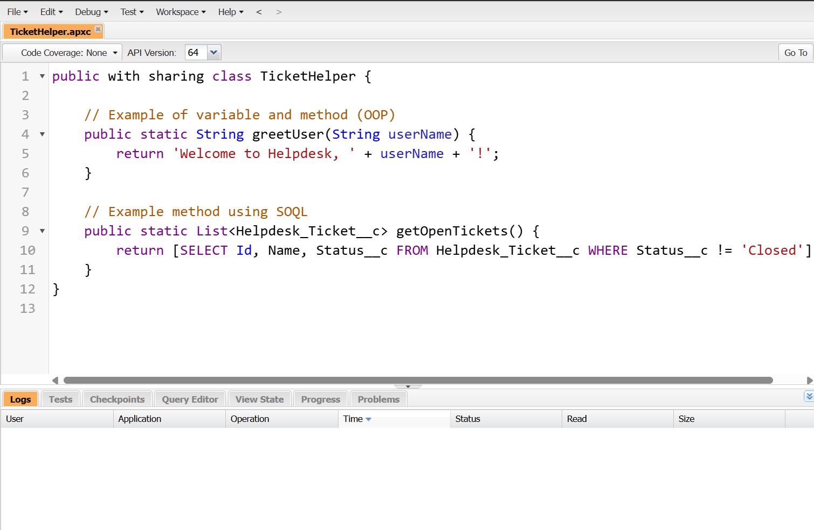

Step 2 — Apex Trigger (Before Insert / After Update)  
Trigger Name: HelpdeskTicketTrigger

trigger HelpdeskTicketTrigger on Helpdesk\_Ticket\_\_c (before insert, after update) {

if (Trigger.isBefore && Trigger.isInsert) {

for (Helpdesk\_Ticket\_\_c t : Trigger.new) {

if (t.Priority\_\_c == null) t.Priority\_\_c = 'Medium';

if (t.Status\_\_c == null) t.Status\_\_c = 'New';

}

}

if (Trigger.isAfter && Trigger.isUpdate) {

for (Helpdesk\_Ticket\_\_c t : Trigger.new) {

if (t.Status\_\_c == 'Resolved' && t.Resolved\_Date\_\_c == null) {

t.Resolved\_Date\_\_c = System.today();

}

}

}

}

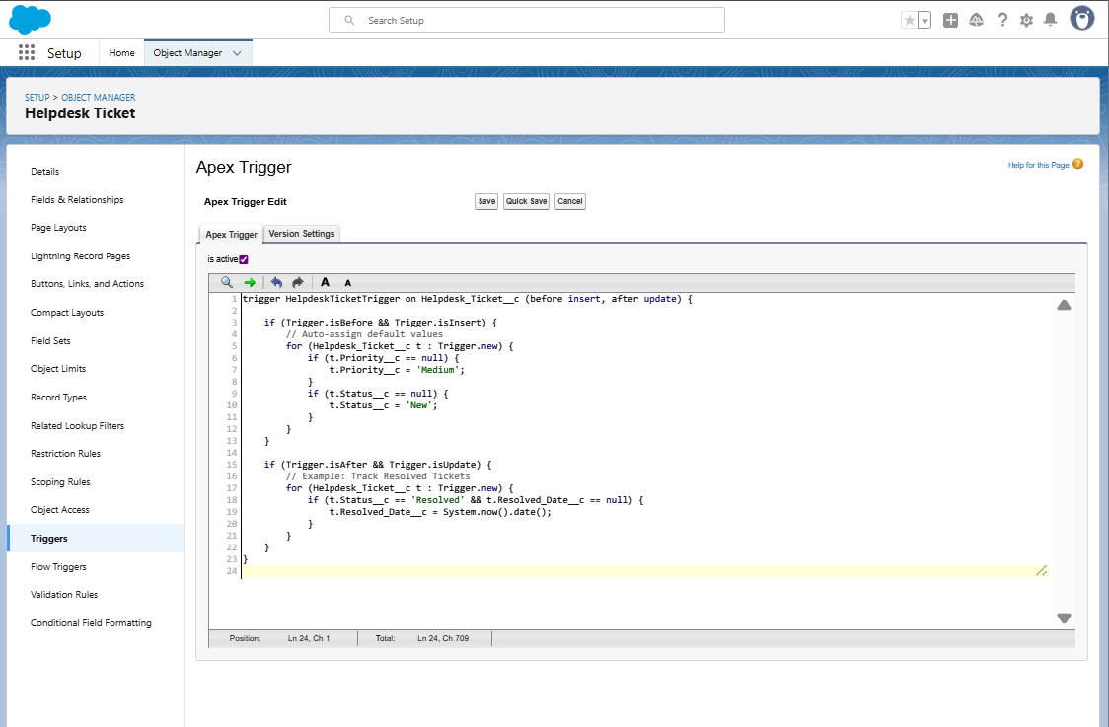

Step 3 — Trigger Design Pattern (Handler Class)  
Class Name: HelpdeskTicketHandler

public with sharing class HelpdeskTicketHandler {

public static void beforeInsert(List<Helpdesk\_Ticket\_\_c> newList) {

for (Helpdesk\_Ticket\_\_c t : newList) {

if (t.Priority\_\_c == null) t.Priority\_\_c = 'Medium';

}

}

public static void afterUpdate(List<Helpdesk\_Ticket\_\_c> newList) {

for (Helpdesk\_Ticket\_\_c t : newList) {

if (t.Status\_\_c == 'Resolved' && t.Resolved\_Date\_\_c == null) {

t.Resolved\_Date\_\_c = Date.today();

}

}

}

}

## Trigger Updated:

trigger HelpdeskTicketTrigger on Helpdesk\_Ticket\_\_c (before insert, after update) {

if (Trigger.isBefore && Trigger.isInsert)

HelpdeskTicketHandler.beforeInsert(Trigger.new);

if (Trigger.isAfter && Trigger.isUpdate)

HelpdeskTicketHandler.afterUpdate(Trigger.new);

}

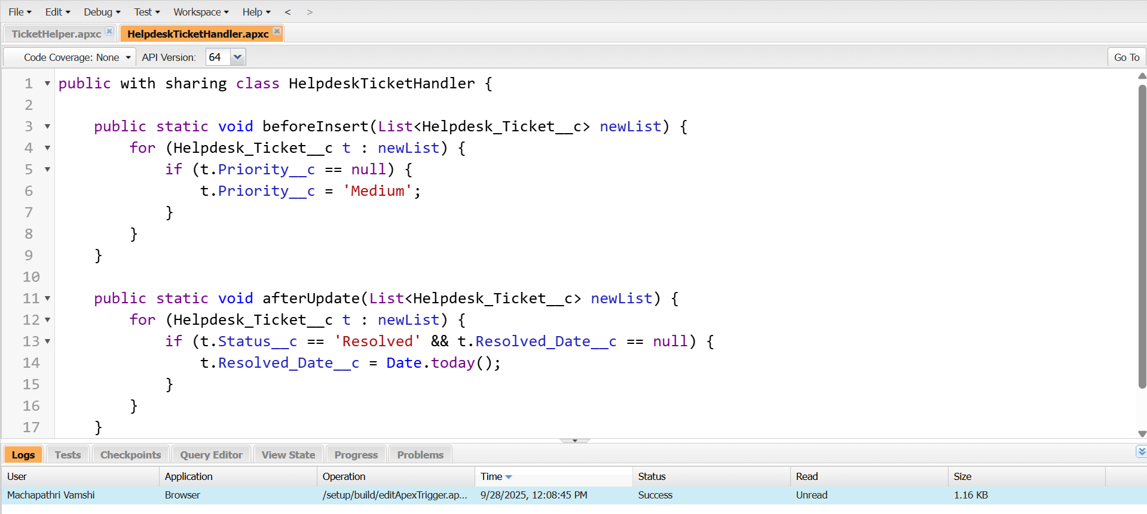

## Step 4 — SOQL & SOSL Queries

List<Helpdesk\_Ticket\_\_c> highPriority = [SELECT Id, Name FROM Helpdesk\_Ticket\_\_c WHERE Priority\_\_c = 'High'];

System.debug('High priority tickets: ' + highPriority);

List<List<SObject>> searchList = [FIND 'Network\*' IN ALL FIELDS RETURNING Helpdesk\_Ticket\_\_c(Name, Category\_\_c)];

System.debug(searchList);

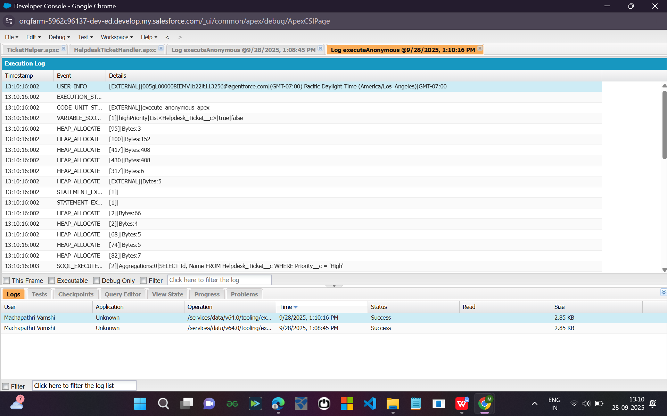

## Step 5 — Collections (List, Set, Map)

List<String> ticketNames = new List<String>{'HT-001', 'HT-002'};

Set<String> categories = new Set<String>{'Network', 'Access'};

Map<Id, Helpdesk\_Ticket\_\_c> ticketMap = new Map<Id, Helpdesk\_Ticket\_\_c>([SELECT Id, Name FROM Helpdesk\_Ticket\_\_c]);

System.debug(ticketNames);

System.debug(categories);

System.debug(ticketMap.keySet());

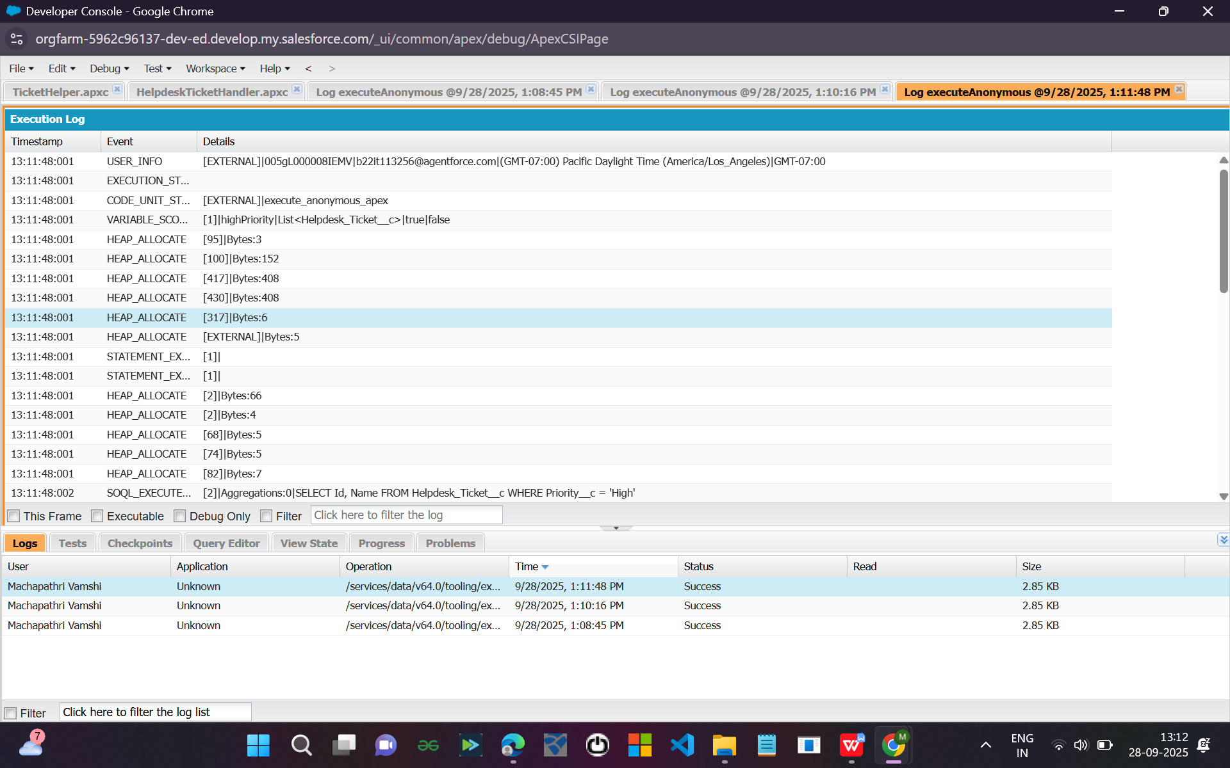

## Step 6 — Control Statements (If, For, While)

for (Helpdesk\_Ticket\_\_c t : [SELECT Status\_\_c FROM Helpdesk\_Ticket\_\_c]) {

if (t.Status\_\_c == 'Resolved') {

System.debug('Resolved Ticket Found!');

} else {

System.debug('Pending Ticket');

}

}

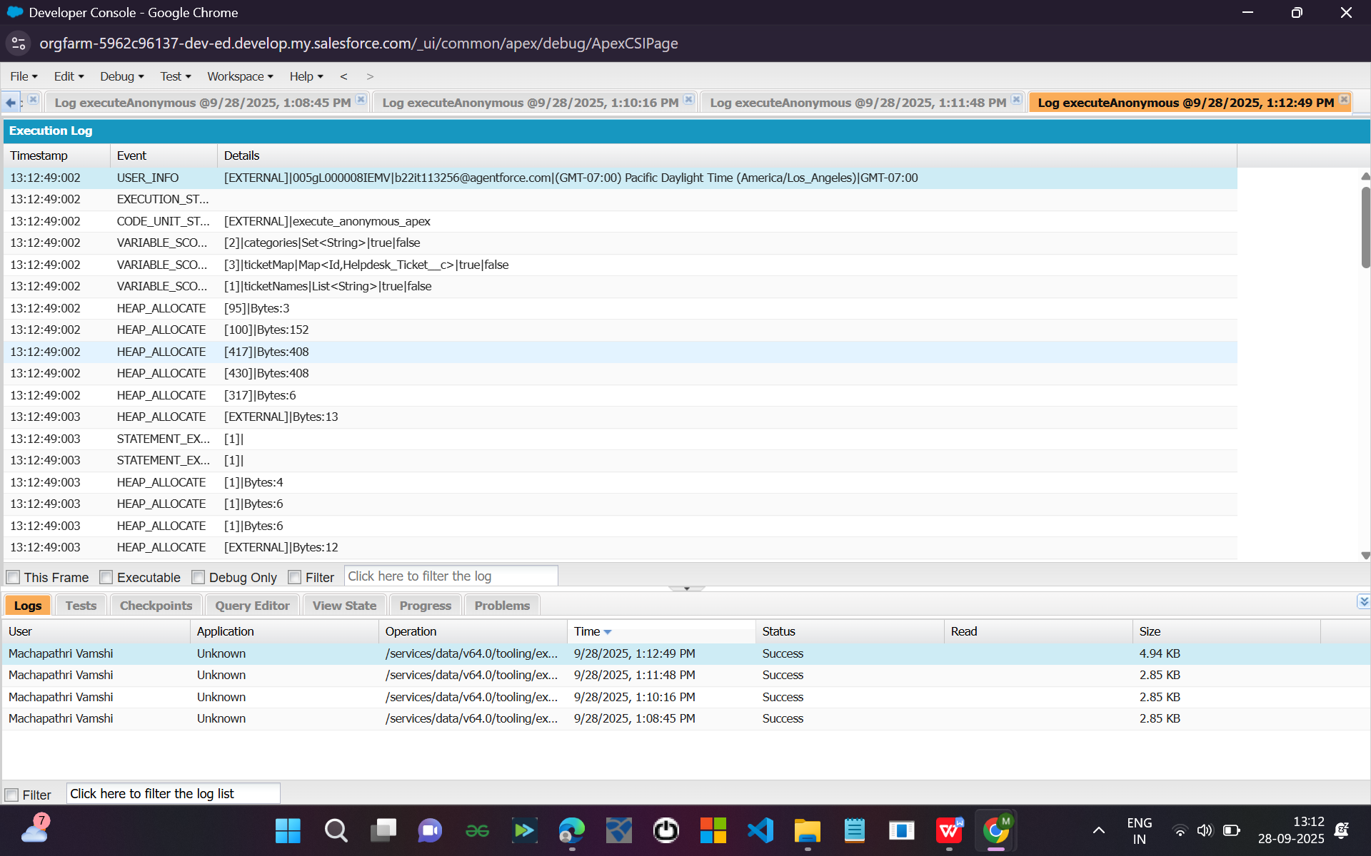

## Step 7 — Future Methods

public with sharing class TicketAsyncHelper {

@future

public static void notifyTeam(String message) {

System.debug('Async Notification Sent: ' + message);

}

}

TicketAsyncHelper.notifyTeam('New Ticket Created');

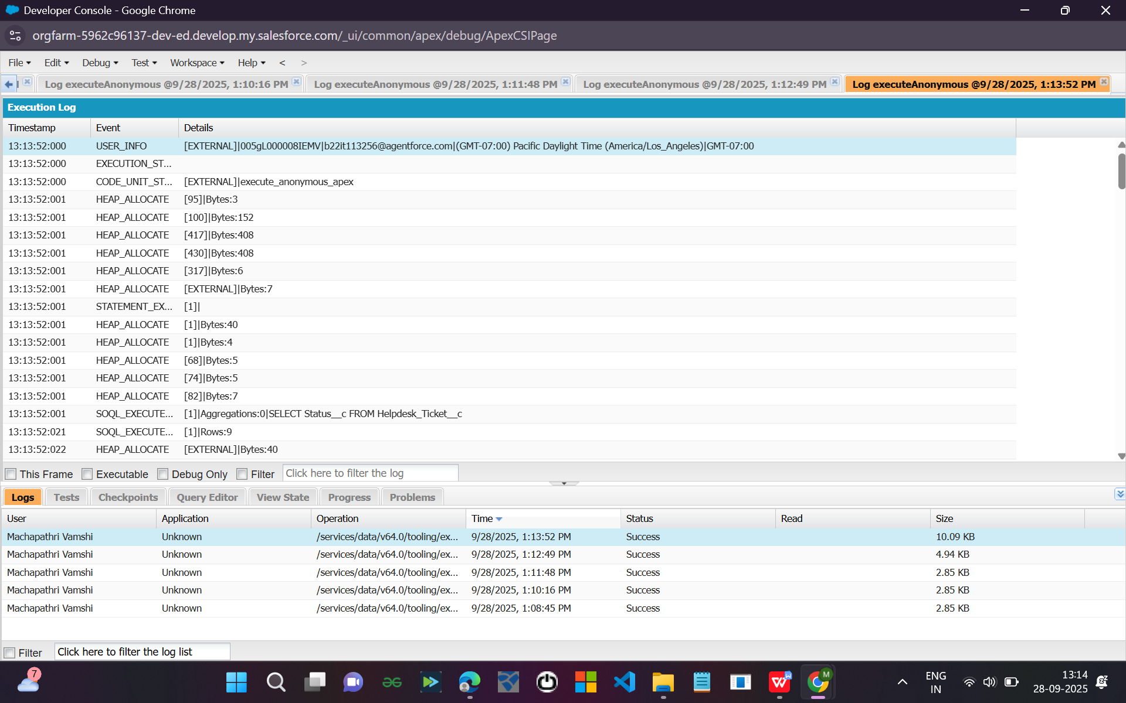

## Step 8 — Batch Apex

public class TicketBatchProcessor implements Database.Batchable<SObject> {

public Database.QueryLocator start(Database.BatchableContext bc) {

return Database.getQueryLocator('SELECT Id FROM Helpdesk\_Ticket\_\_c WHERE Status\_\_c = 'Resolved'');

}

public void execute(Database.BatchableContext bc, List<Helpdesk\_Ticket\_\_c> scope) {

for (Helpdesk\_Ticket\_\_c t : scope) {

System.debug('Processing Ticket: ' + t.Id);

}

}

public void finish(Database.BatchableContext bc) {

System.debug('Batch Completed');

}

}

Database.executeBatch(new TicketBatchProcessor());

## Step 9 — Queueable Apex

public class TicketQueueJob implements Queueable {

public void execute(QueueableContext qc) {

System.debug('Queue Job Executed');

}

}

ID jobId = System.enqueueJob(new TicketQueueJob());

## Step 10 — Scheduled Apex

public class TicketScheduler implements Schedulable {

public void execute(SchedulableContext sc) {

System.debug('Daily Ticket Job Executed');

}

}

Schedule via Setup → Apex Classes → Schedule Apex

## Step 11 — Exception Handling

try {

List<Helpdesk\_Ticket\_\_c> t = [SELECT Id FROM Helpdesk\_Ticket\_\_c WHERE Name = 'Invalid'];

} catch (Exception e) {

System.debug('Error: ' + e.getMessage());

}

## Step 12 — Test Class

@isTest

public class TicketHelperTest {

@isTest

static void testGreetUser() {

String result = TicketHelper.greetUser('Vamshi');

System.assertEquals('Welcome to Helpdesk, Vamshi!', result);

}

@isTest

static void testTriggerInsert() {

Helpdesk\_Ticket\_\_c t = new Helpdesk\_Ticket\_\_c(Category\_\_c='Network', Description\_\_c='Testing trigger');

insert t;

System.assertNotEquals(null, t.Priority\_\_c);

}

}

# Phase 6 – User Interface Development (Step-by-Step Guide)

## Objective

To build a **modern, user-friendly Lightning interface** for your Helpdesk Ticket Management System using **Lightning App Builder**, **Record Pages**, **Utility Bar**, and **Lightning Web Components (LWC)** integrated with Apex.

This phase ensures your users (Employee, IT Support, Manager) get a clean and interactive experience.

## 🧩 Step 1 — Create a Custom Lightning App

🧭 **Path:** Setup → App Manager → **New Lightning App**

1. Click **New Lightning App**  
   2. Fill:

* App Name: Helpdesk Support
* Developer Name: Helpdesk\_Support
* Description: App for managing IT Helpdesk Tickets
* Click **Next**

3. Select Navigation Style: Standard Navigation → **Next**  
4. Choose Utility Items (optional): Add **Recent Items**, **Notes**, **Open Cases** → **Next**  
5. Assign App to profiles: Select System Administrator, IT Support, Employee → **Save & Finish**

✅ **Expected Outcome:** New Lightning app named “Helpdesk Support” appears in App Launcher.

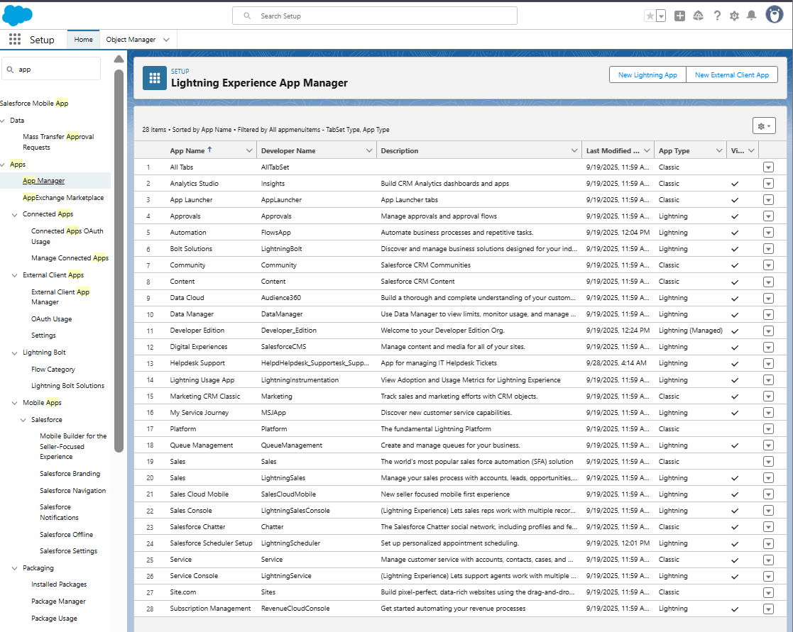

## Step 2 — Create Tabs

**Path:** Setup → Tabs → Custom Object Tabs

1. Click **New**  
   2. Select Object: **Helpdesk Ticket**  
   3. Tab Style: Choose any icon (e.g., Clipboard or Wrench)  
   4. Assign to profiles → **All Profiles**  
   5. Click **Save**

✅ **Expected Outcome:** Helpdesk Ticket tab visible in Lightning App.

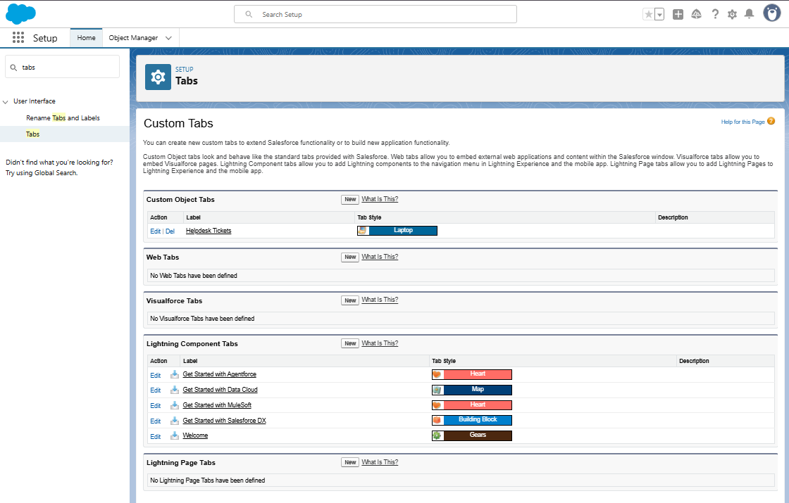

## Step 3 — Customize Record Pages (Lightning App Builder)

🧭 **Path:** Setup → Object Manager → Helpdesk Ticket → Lightning Record Pages

1. Click **New** → Type: **Record Page**  
   2. Name: Helpdesk\_Ticket\_Record\_Page  
   3. Choose Template: **Header and Right Sidebar** → **Finish**

In the page editor:

* Drag standard components: **Highlights Panel**, **Record Detail**, **Related Lists**, **Tabs**
* Add **Custom Components** (like your LWC, once created)
* Save → **Activate** → Set as **Org Default**

✅ **Expected Outcome:** Record page shows clean, modern layout.

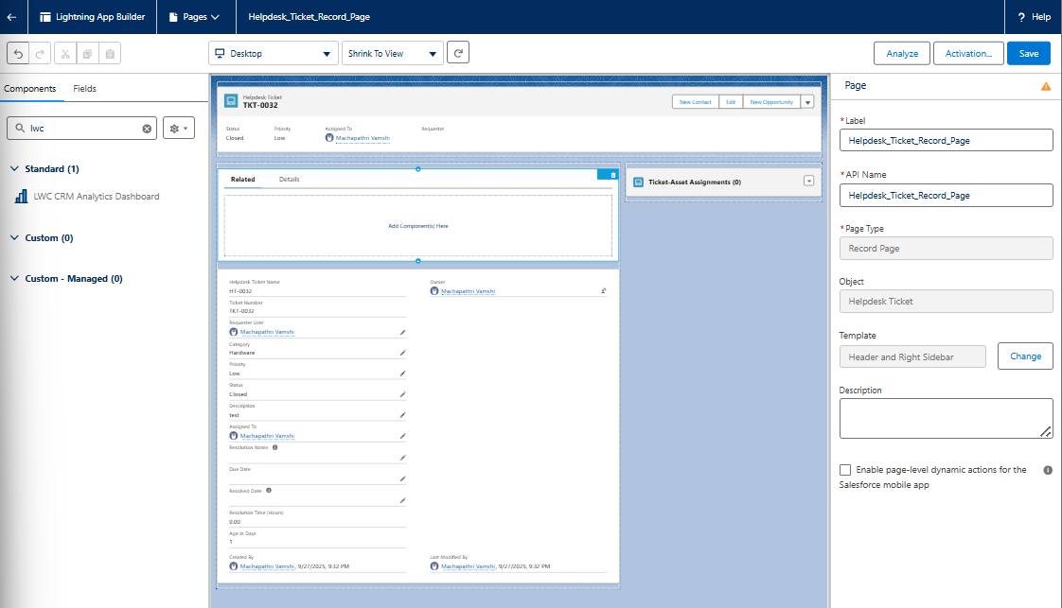

## Step 4 — Customize Home Page Layout

🧭 **Path:** Setup → Lightning App Builder → **New Page → Home Page**

1. Name: Helpdesk Home  
   2. Add Components:

* **Recent Items** (object = Helpdesk Ticket)
* **Dashboard** (optional)
* **List View**
* **Custom Text / Image** for Welcome

1. Click **Save → Activate → Assign to App = Helpdesk Support**

✅ **Expected Outcome:** Users see customized home page.

* Screenshot Placeholder: Home Page Layout

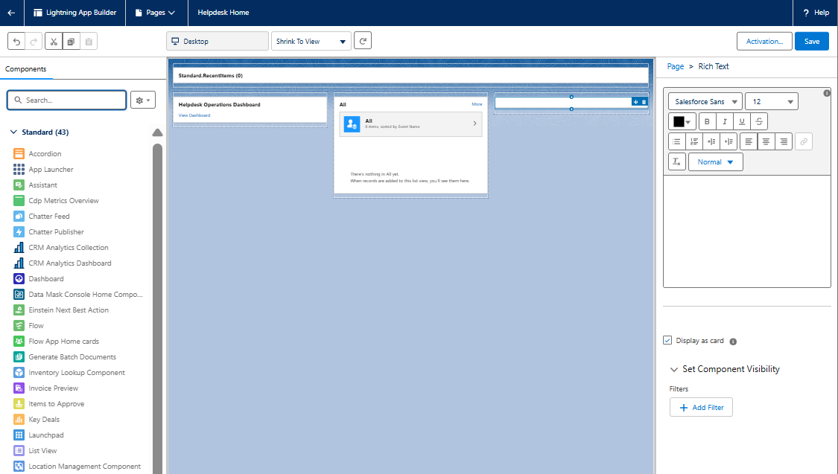

## Step 5 — Add Utility Bar Items

**Path:** Setup → App Manager → Edit “Helpdesk Support”

1. Go to **Utility Items (Desktop Only)**  
   2. Click **Add Utility Item** → choose:

* **Notes**
* **Recent Items**
* **History**

1. Save & Finish

✅ **Expected Outcome:** Utility bar visible at bottom of Lightning UI.

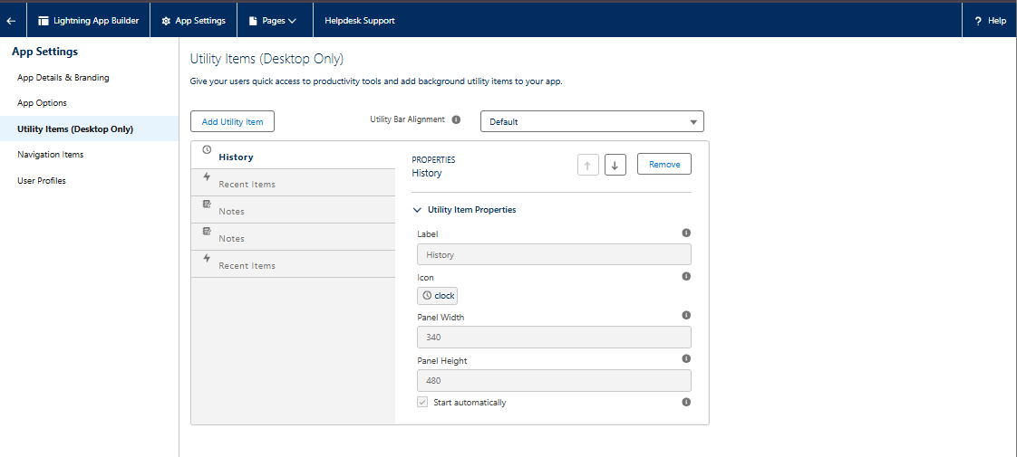

## Step 6 — Create Lightning Web Component (LWC)

🧭 **Path:** VS Code / Salesforce CLI Workspace

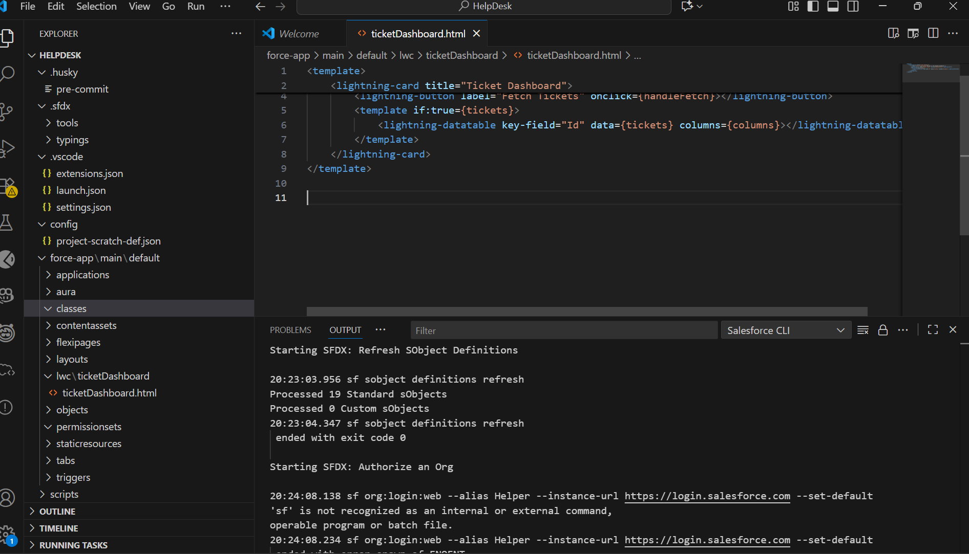

## Step 7 — Create Apex Controller for LWC

🧭 **Path:** Developer Console → File → New → Apex Class

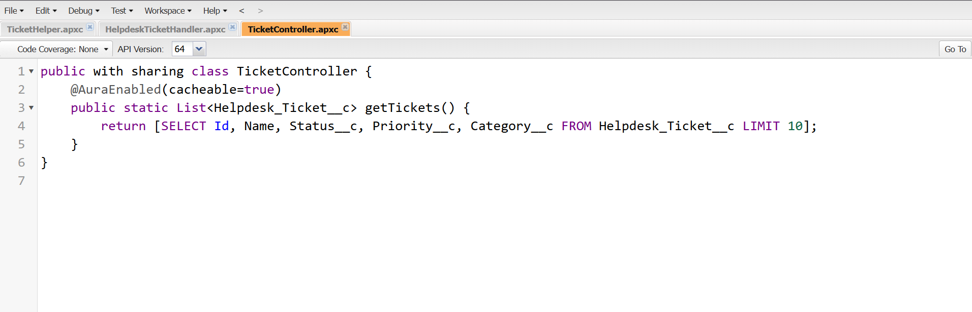

## Step 8 — Wire Adapter Example

Modify JS file to auto-load data on load:

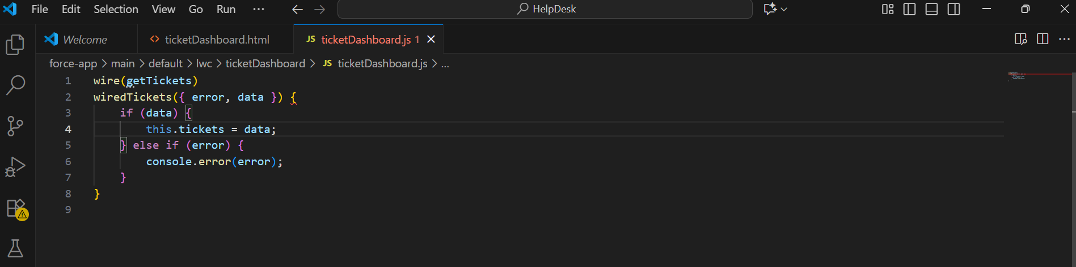

## Step 10 — Event Handling in LWC

Add custom event to notify parent:

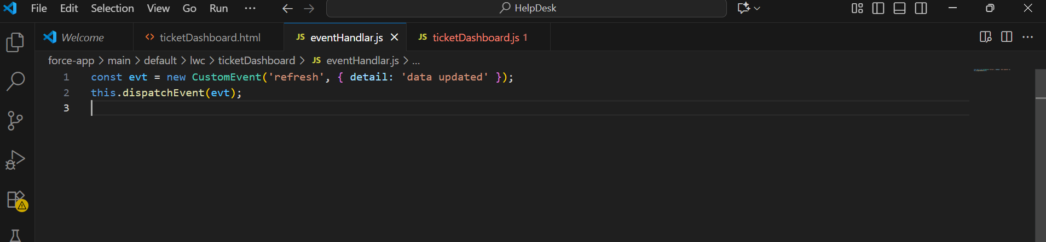

## Step 11 — Navigation Service Example

Add navigation from LWC to record:

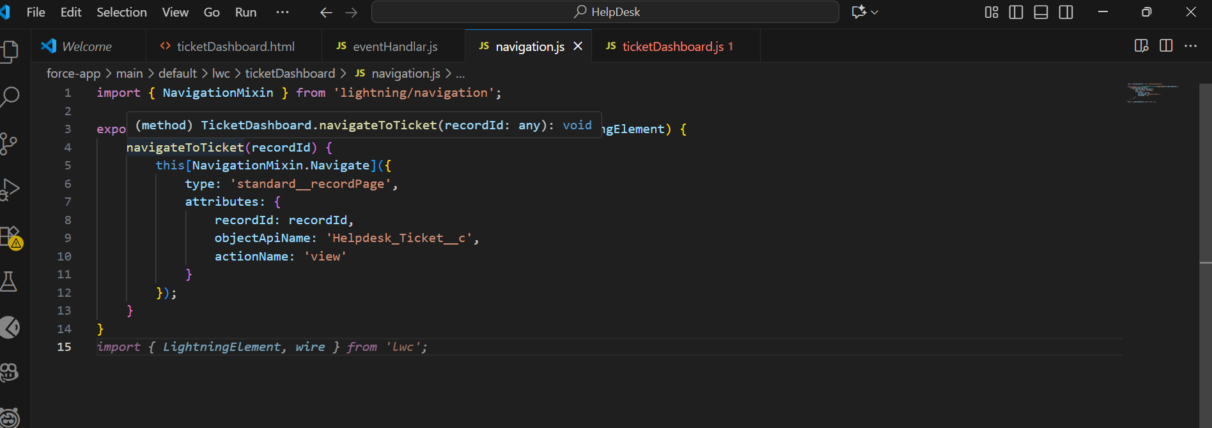

## Step 12 — Add LWC to Lightning Page

**Path:** Setup → Object Manager → Helpdesk Ticket → Lightning Record Page

1. Edit the record page in **Lightning App Builder**  
2. From Custom Components, drag ticketDashboard into the layout  
3. Save & Activate

✅ **Expected Outcome:** LWC visible inside Ticket Record Page.

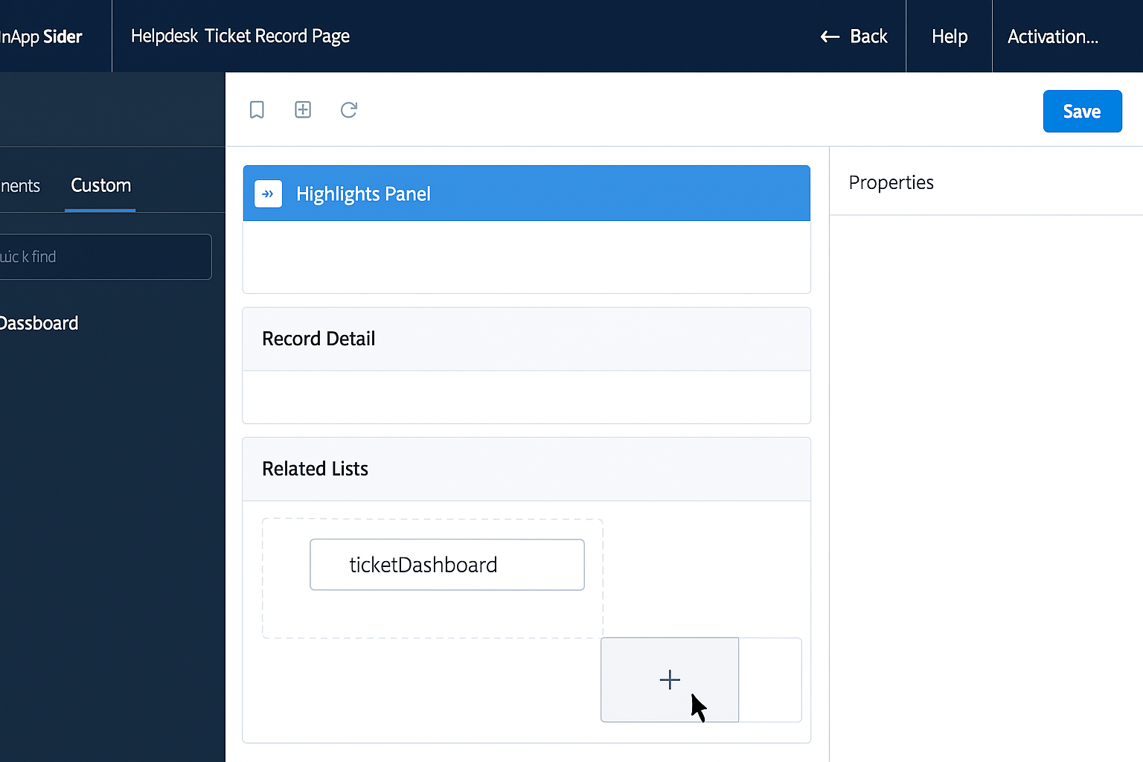

# Phase 7 – Integration & External Access

## Objective

Enable your Salesforce Helpdesk App to **integrate securely** with external services, expose APIs, and manage data sync using:

* Named Credentials
* Callouts (REST/SOAP)
* Platform Events
* Salesforce Connect
* OAuth Authentication
* Remote Site Settings

## Step 1 — Enable API Access (Pre-check)

1️⃣ Log in as **System Administrator**.  
2️⃣ Setup → **Profiles** → open your **System Administrator** and **IT Manager** profiles.  
3️⃣ Under **Administrative Permissions**, confirm:

✅ API Enabled

✅ View All Data

✅ Modify All Data

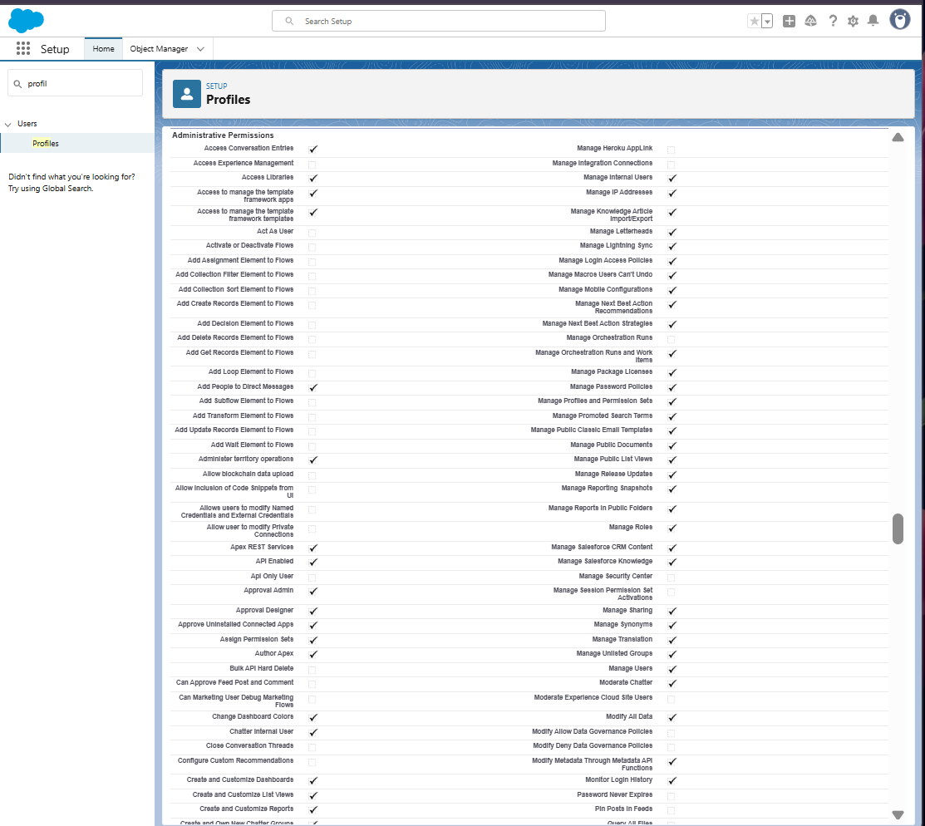

## Step 2 — Configure Remote Site Settings

Salesforce only allows callouts to **trusted domains** — we must whitelist external API endpoints.

1. Setup → **Remote Site Settings** → **New Remote Site**  
   2. Fill details:

* **Remote Site Name:** External\_API\_Site
* **Remote Site URL:** https://jsonplaceholder.typicode.com (for demo REST API)
* **Active:** ✅

3. Click **Save**

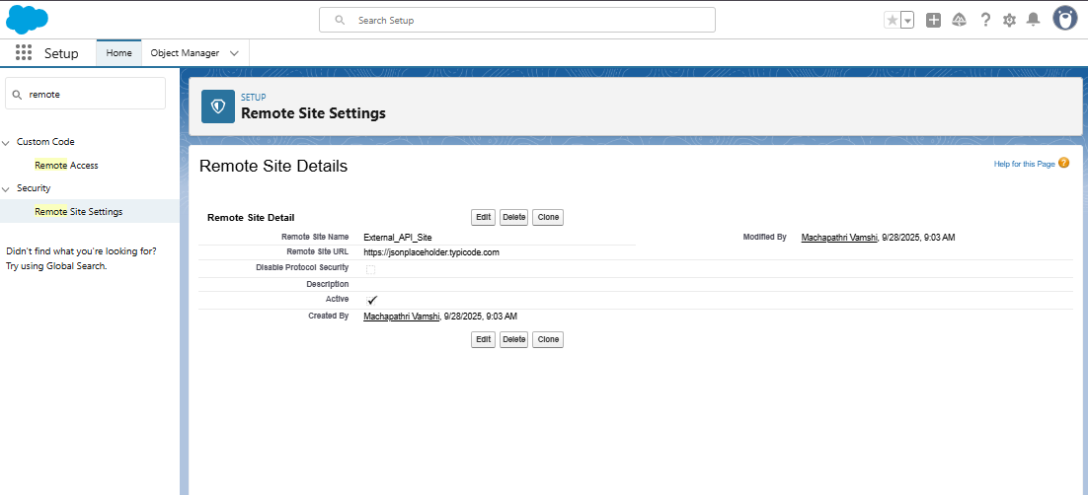

## Step 3 — Create Named Credential (secure auth wrapper)

Named Credentials store endpoint + authentication in one place — your Apex or Flow just references the name, not credentials.

1. Setup → **Named Credentials** → **New**  
   2. Example:

**Label:** JSONPlaceholder\_API

**Name:** JSONPlaceholder\_API

**URL:** https://jsonplaceholder.typicode.com

**Identity Type:** Anonymous (no login needed for demo)

**Authentication Protocol:** None

3. Click **Save**

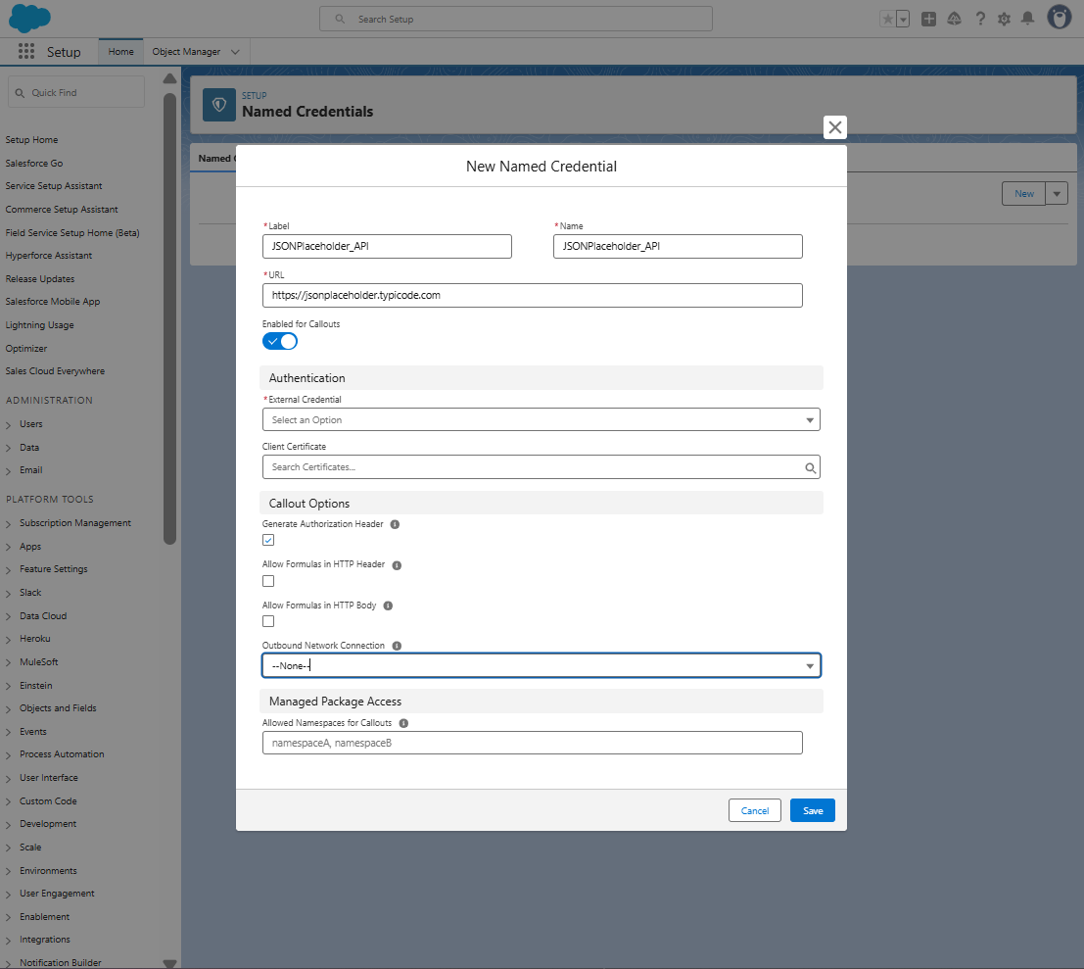

## Step 4 — Test a REST API Callout (Apex)

We’ll fetch external data (e.g., user info) using Apex.

1. Go to **Developer Console** → **Execute Anonymous Window**

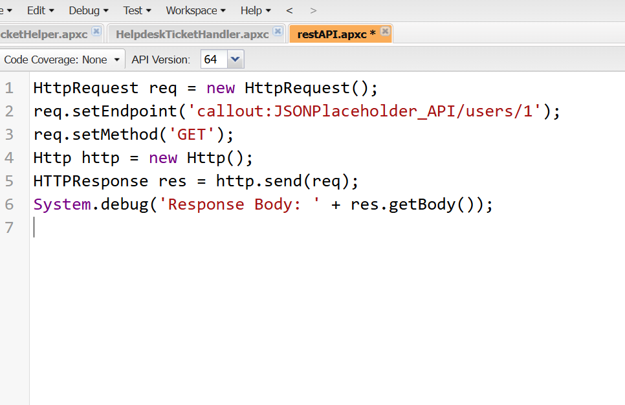

## Step 5 — Create External Services (Flow Integration)

Allows declarative (no code) integration using OpenAPI Schema.

1. Setup → **External Services** → **New External Service**  
   2. Provide name: JSONPlaceholderService  
   3. Upload an OpenAPI spec (or use a sample public API URL if available).  
   4. Click **Save & Next**.  
   5. Salesforce auto-creates **Apex actions** for use in Flow.

## Step 6 — Platform Events (Real-Time Notifications)

Platform Events = publish-subscribe model for real-time triggers.

1. Setup → **Platform Events** → **New Platform Event**

* **Label:** Ticket\_Update\_Event
* **API Name:** Ticket\_Update\_Event\_\_e
* Add custom field: **Field Name:** Status\_\_c (Text, 50)

1. Save.

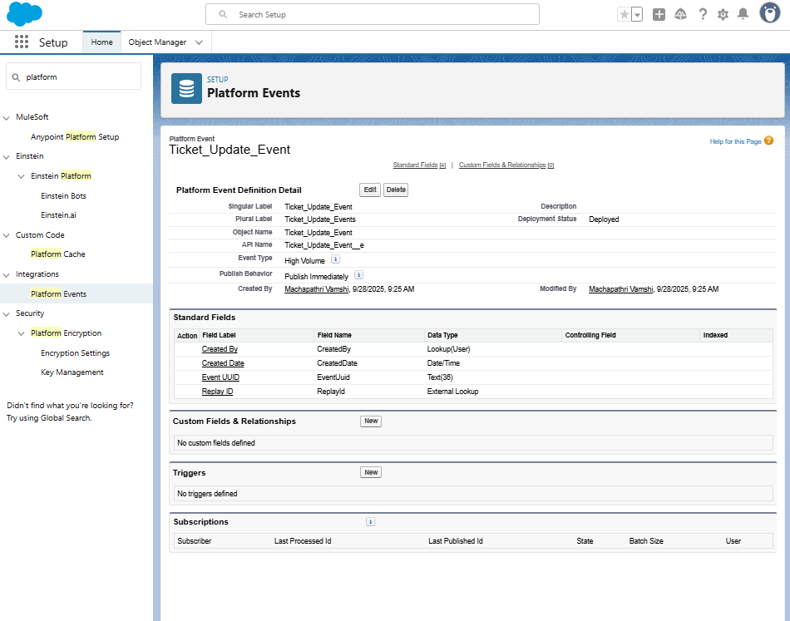

## Step 7 — Change Data Capture (CDC)

Use CDC to sync Helpdesk Tickets in real-time with external apps.

1. Setup → **Change Data Capture** → **Select Helpdesk Ticket**  
   2. Move it to **Selected Entities** → **Save**

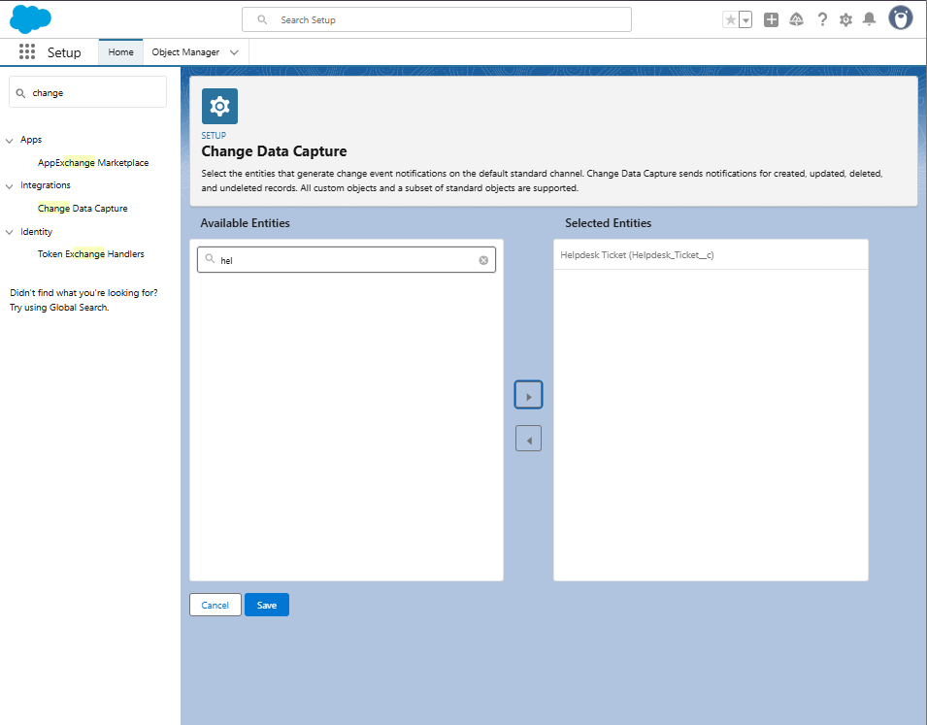

## Step 8 — Salesforce Connect (External Objects)

View external database data in Salesforce without storing it.

1. Setup → **External Data Sources** → **New External Data Source**  
    Example:

**Label:** External\_Data\_Demo

**Type:** OData 4.0

**URL:** (use sample service like <https://services.odata.org/V4/Northwind/Northwind.svc/)>

1. Click **Save → Validate and Sync** → select objects to sync

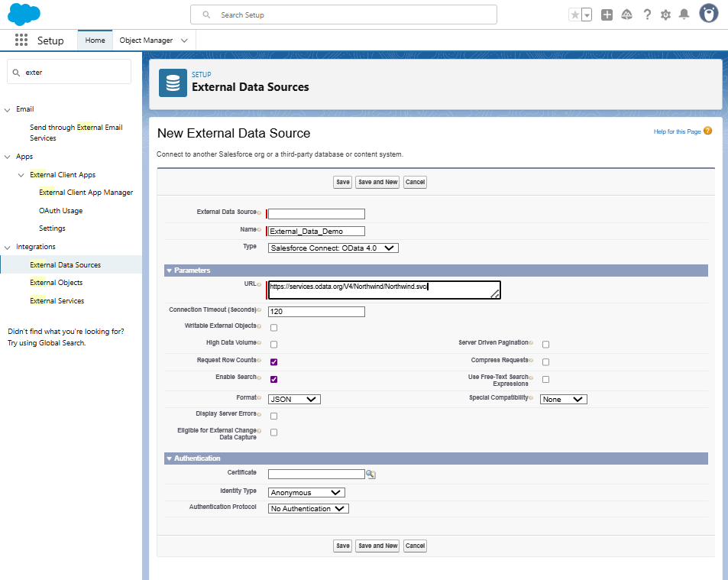

## Step 9 — Monitor API Usage

1. Setup → **System Overview**  
   2. Look under **API Usage (Last 24 hours)**  
   3. Click for details → Monitor API call counts.

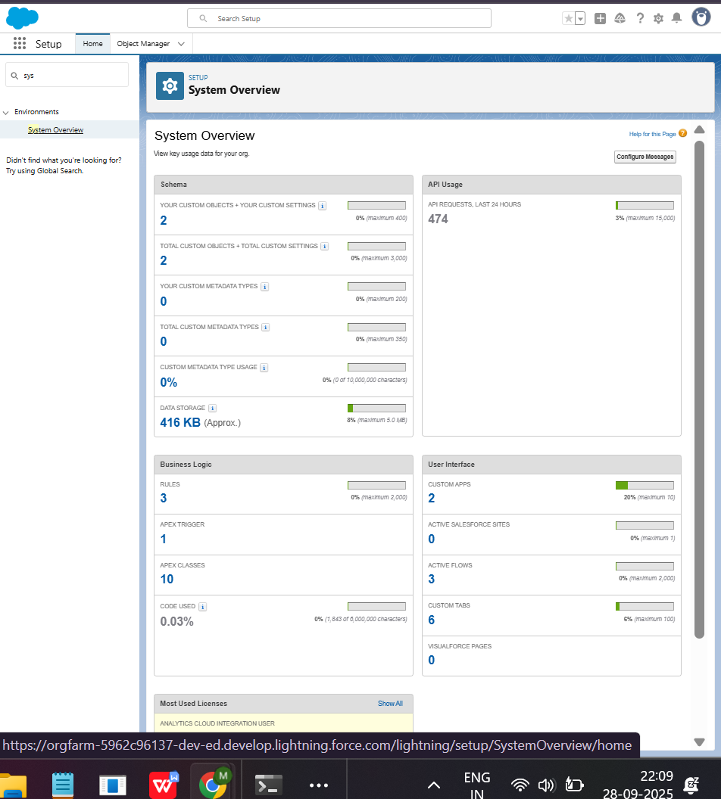

# Phase 8 – Data Management & Deployment

## Objective

To manage Helpdesk Ticket data safely and deploy configurations (objects, fields, code) from your **Developer Org** to a **Target Org** (like Production or another Sandbox).

You’ll use:

* Import Wizard & Data Loader (for data)
* Duplicate Rules (for data quality)
* Export (for backup)
* Change Sets, Packages, ANT, and SFDX (for deployment)

## Step 1 — Data Import Wizard (UI-based import)

**Path:** Setup → Data Import Wizard → Launch Wizard

1. Choose Object: **Helpdesk Ticket**  
   2. Choose **Add New Records**  
   3. Upload CSV file (create in Excel — e.g.):

| **Requester\_\_c** | **Category\_\_c** | **Priority\_\_c** | **Status\_\_c** |
| --- | --- | --- | --- |
| [User ID] | Network | High | New |
| [User ID] | Access | Medium | In Progress |

1. Click **Next → Map Fields Automatically → Import**

✅ **Expected Outcome:** Tickets imported successfully (check under App Launcher → Helpdesk Tickets).

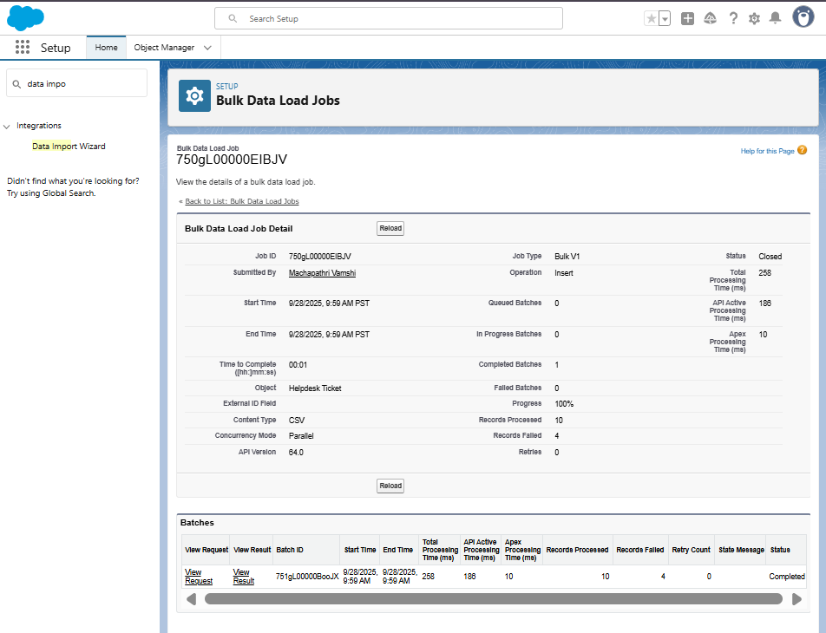

## Step 2 — Data Loader (for bulk import/export/update/delete)

Data Loader = desktop app for large volume data (50,000+ records).

1. Download from **Setup → Data Loader**.  
   2. Launch Data Loader → Login (Production/Sandbox).  
   3. Choose an operation:

**Insert** (add records)

**Update** (modify)

**Upsert** (insert/update)

**Export** (backup)

**Delete** (remove records)

Example:

Choose **Insert** → Select Object = Helpdesk\_Ticket\_\_c

Browse CSV file → Click **Next → Map Fields Automatically → Finish**

✅ **Expected Outcome:** Records inserted/updated in bulk

## Step 3 — Duplicate Rules (Data Quality Control)

**Path:** Setup → Duplicate Rules → New Rule

1. Object: **Helpdesk Ticket**  
   2. Rule Name: Duplicate Ticket Rule  
   3. Condition:

Field: Requester\_\_c

Operator: Exact Match

Add another filter: Category\_\_c = Exact Match

1. Select **Action = Block** duplicate record creation.  
   5. Save → Activate

✅ **Expected Outcome:** Users can’t create duplicate tickets for same Requester + Category.

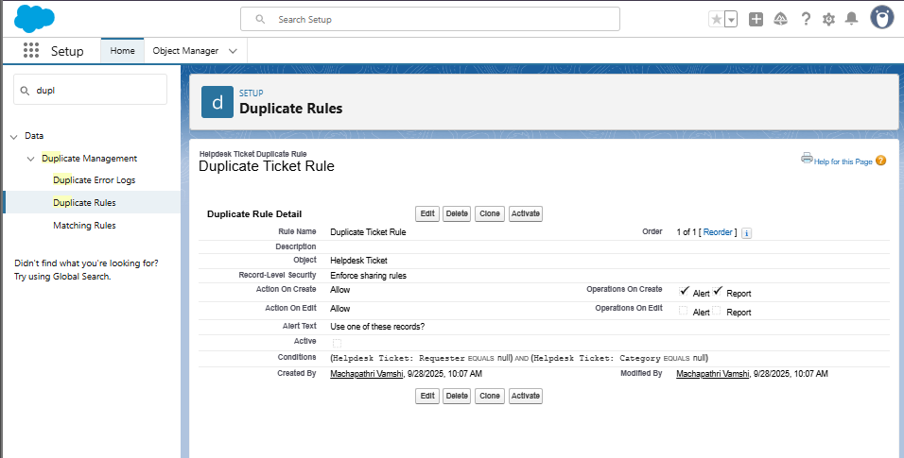

## Step 4 — Data Export & Backup

**Path:** Setup → Data Export → **Export Now**

1. Select **Helpdesk Ticket** and other related objects (User, Category if applicable).  
   2. Check “Include images, documents, attachments”.  
   3. Click **Start Export**.  
   4. After completion → Download .zip backup file.

✅ **Expected Outcome:** Complete data backup zip available.

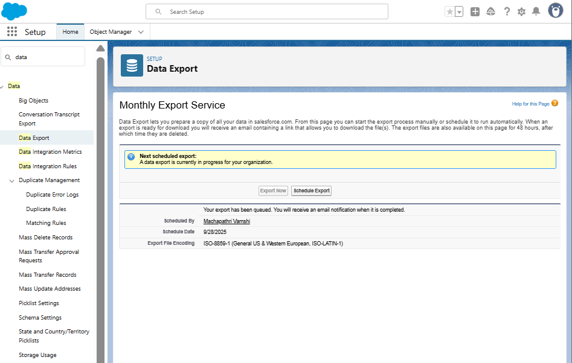

## Step 5 — Managed vs Unmanaged Packages

| **Type** | **Description** | **Use Case** |
| --- | --- | --- |
| **Managed** | Versioned, locked components (AppExchange apps) | Distribute to customers |
| **Unmanaged** | Editable components, for training/projects | Student Projects / Internal use |

Setup → Packages → **New**  
1. Name: Helpdesk\_Project\_Package  
2. Select components (Object, LWC, Apex)  
3. Save → **Upload** → Choose “Unmanaged”

✅ **Expected Outcome:** .zip link generated, usable in another org.

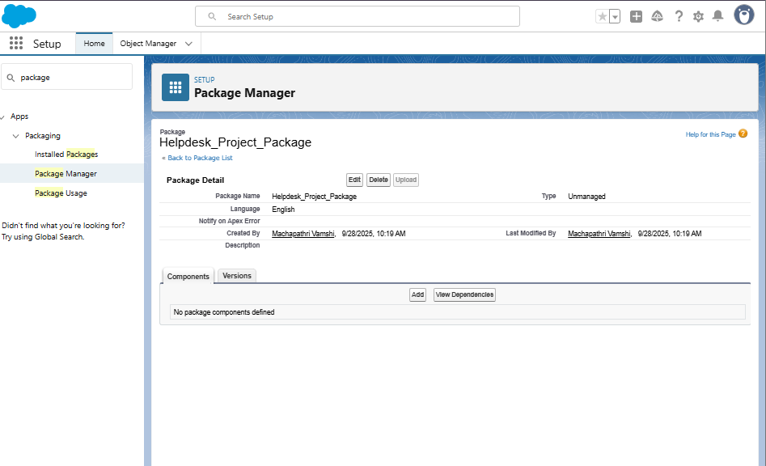

## Step 6 — VS Code & SFDX (Modern DevOps)

SFDX (Salesforce CLI) = new-gen DevOps toolset (better than ANT).

### Setup:

1. Install:

VS Code

Salesforce CLI

Salesforce Extension Pack

1. Open Terminal:

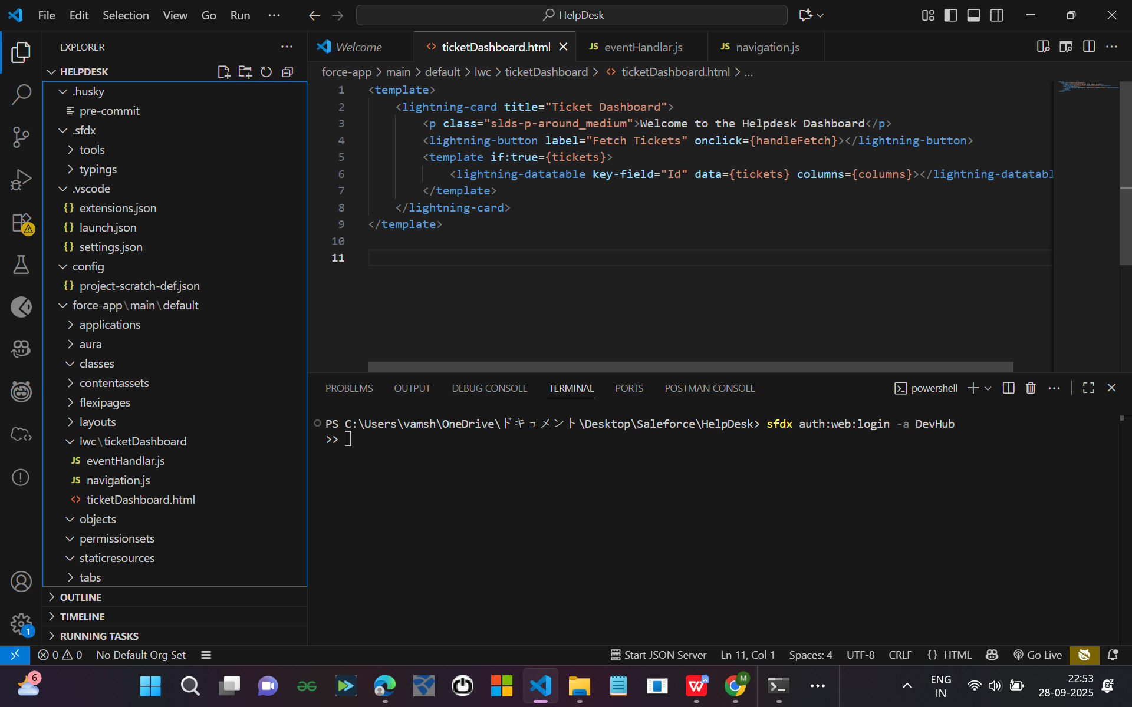

# Phase 9 — Reports & Dashboards

PRE-CHECK (do this first)  
Log in as System Administrator.  
Confirm Helpdesk Ticket object exists: Setup → Object Manager → Helpdesk Ticket.  
Confirm there are a few sample records (6–10) for testing.  
  
PART A — Add two helper fields (Age and Resolved Date + Resolution Hours Formula)  
**A1 — Create Resolved Date (Date/Time)**  
- Setup → Object Manager → Helpdesk Ticket → Fields & Relationships → New.  
- Data Type: Date/Time → Next.  
- Field Label: Resolved Date → API Name: Resolved\_Date\_\_c.  
- Help Text: Date/time when ticket was marked Resolved.  
- Visible on all layouts → Save.

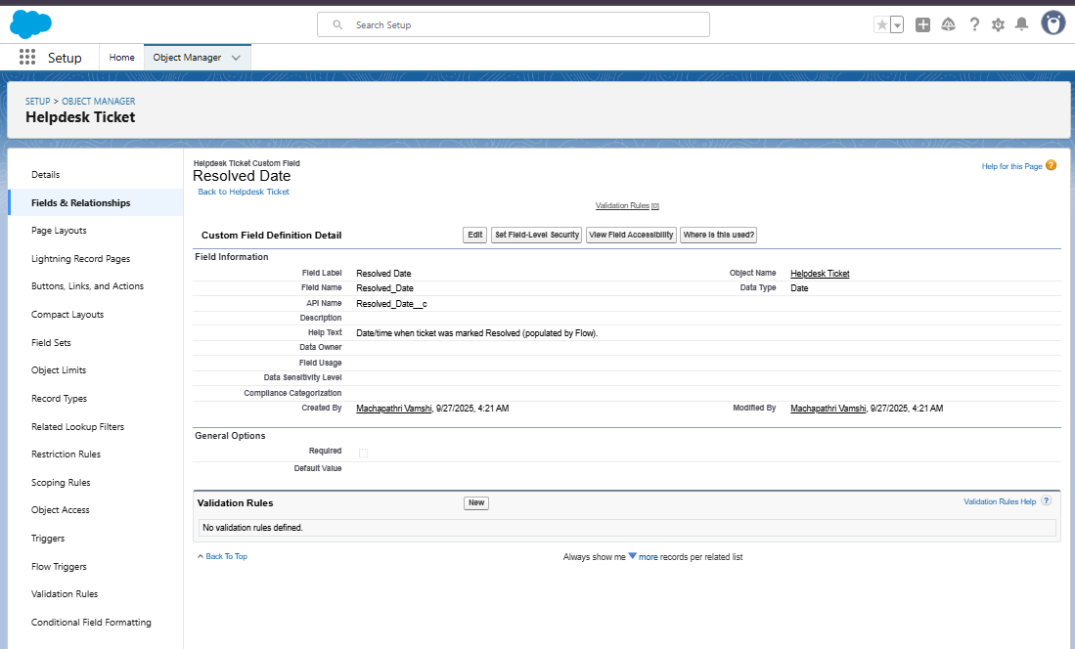

**A2 — Create Resolution Time (Hours) (Formula Number)**  
- Data Type: Formula → Return Type: Number (2 decimals).  
- Formula: **IF(  
 ISBLANK(Resolved\_Date\_\_c),  
 0,  
 (Resolved\_Date\_\_c - CreatedDate) \* 24  
 )  
- Check syntax and save.**  
  
A3 — Create Age in Days (Formula Number)  
Formula: **TODAY() - DATEVALUE(CreatedDate)  
Save and add to layout.**

PART B — Flow to populate Resolved Date  
- Setup → Flows → New Flow → Record-Triggered Flow.  
- Object: Helpdesk Ticket.  
- Condition: Status = Resolved AND Resolved\_Date\_\_c IS BLANK.  
- Action: Update Record → Resolved\_Date\_\_c = $Flow.CurrentDateTime.  
- Save and Activate.

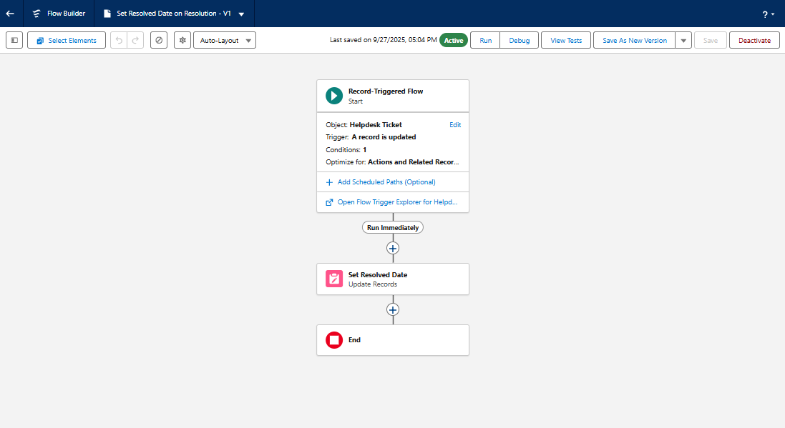

PART C — Create Report Folders  
C1 — Reports Folder: Helpdesk Reports  
C2 — Dashboard Folder: Helpdesk Dashboards  
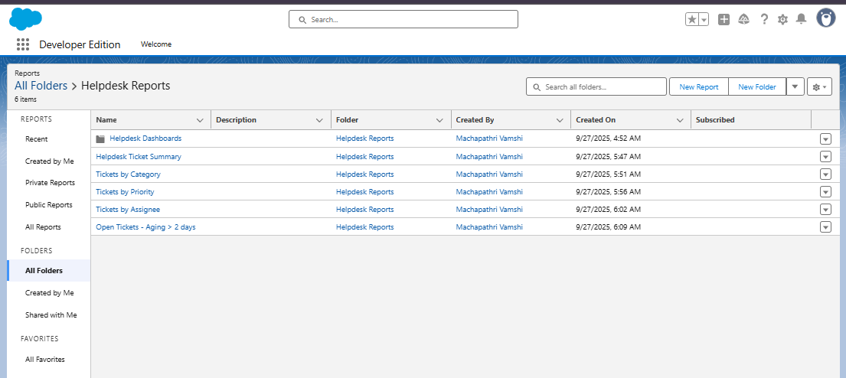

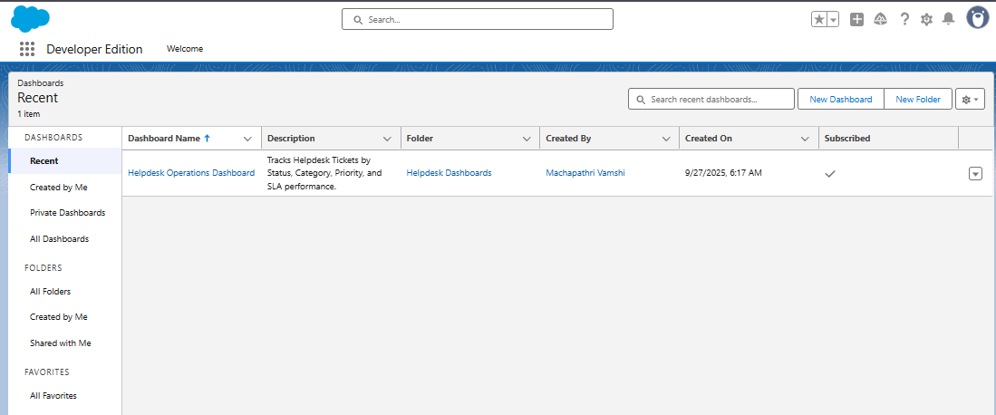

PART D — Build Reports  
D1 — Helpdesk Ticket Summary (by Status)  
- Group Rows by Status.  
- Add Donut Chart.

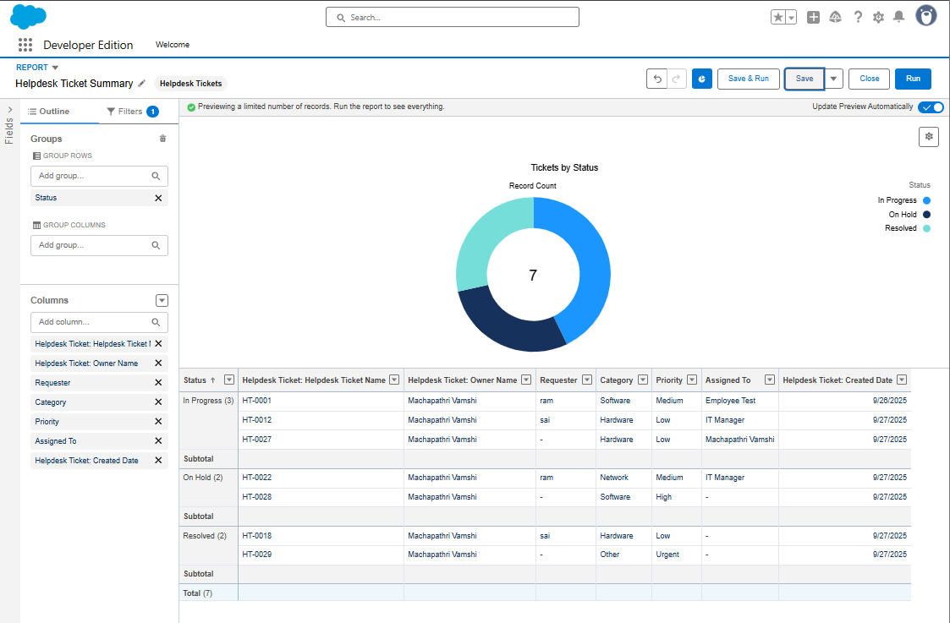

D2 — Tickets by Category  
- Group Rows by Category.  
- Add Bar Chart.

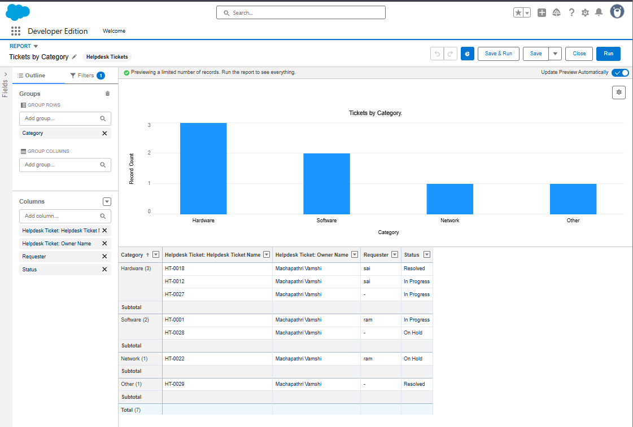  
D3 — Tickets by Priority  
- Group Rows by Priority.  
- Add Donut Chart.

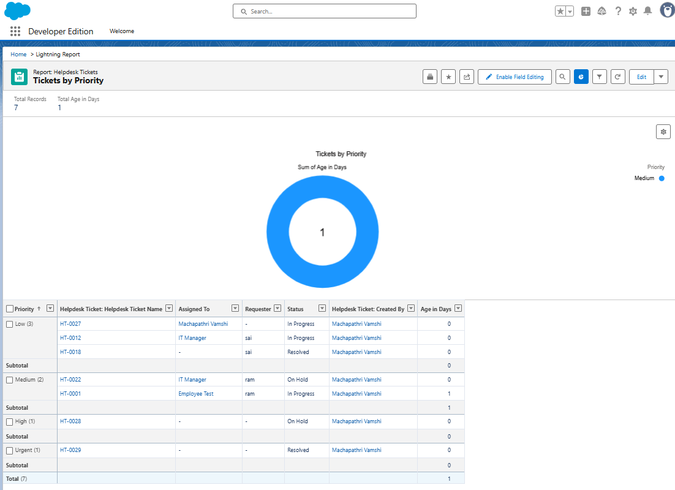

D4 — Tickets by Assignee  
- Group Rows by Assigned To.  
- Add Horizontal Bar Chart.

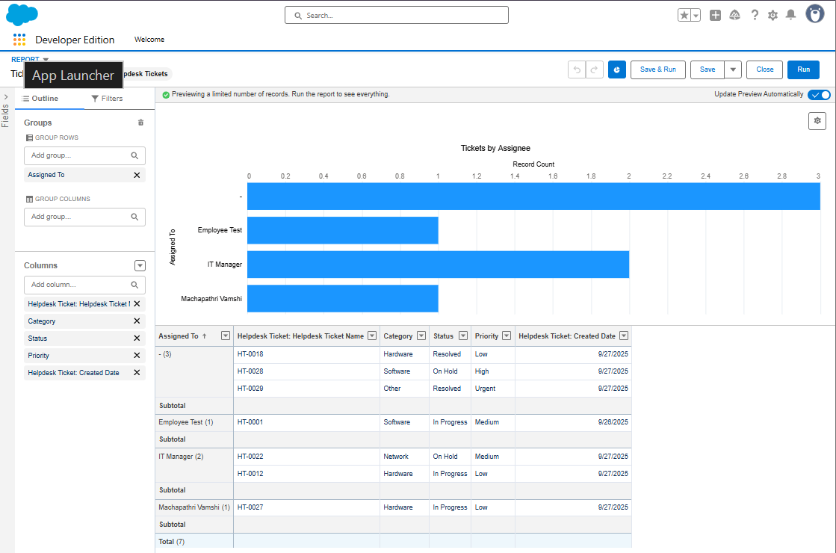

D5 — Open Tickets Aging (>2 Days)  
- Filter: Status not Resolved, Age\_in\_Days\_\_c > 2.  
- Add Table format

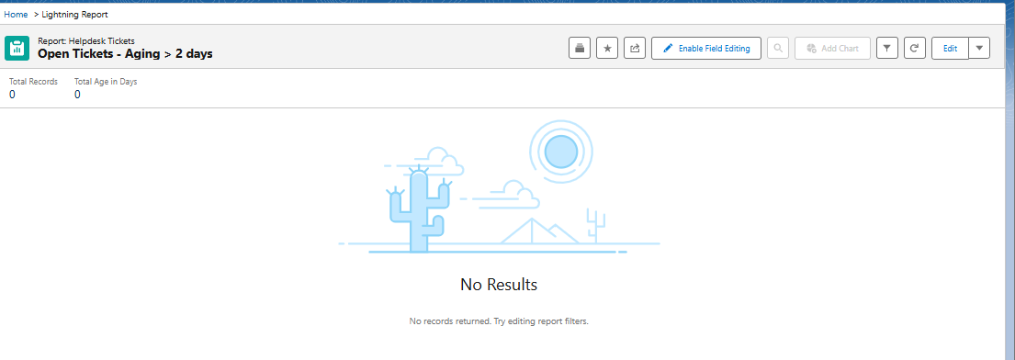.

D6 — Average Resolution Time (Hours)  
- Filter: Resolved Date not Blank.  
- Add Summary on Resolution Time (Hours) column.  
- Add Gauge Chart.

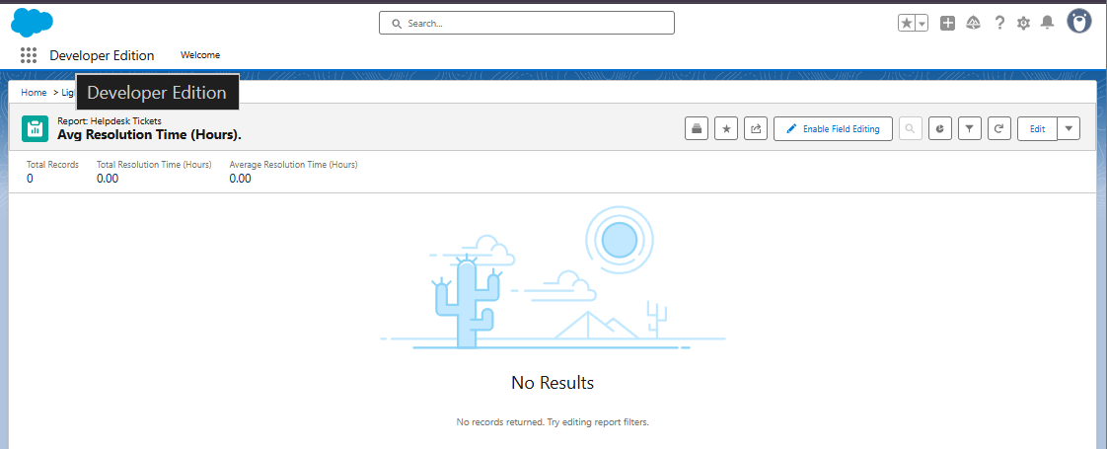  
PART E — Create Dashboard  
E1 — Dashboard Name: Helpdesk Operations Dashboard.  
E2 — Add Components:  
 1. Tickets by Status (Donut)  
 2. Tickets by Category (Bar)  
 3. Tickets by Assignee (Horizontal Bar)  
 4. Open Tickets Aging (Table)  
 5. Avg Resolution Time (Metric)  
 6. Tickets by Priority (Stacked Bar)  
E3 — Add Filters: Status, Assigned To.

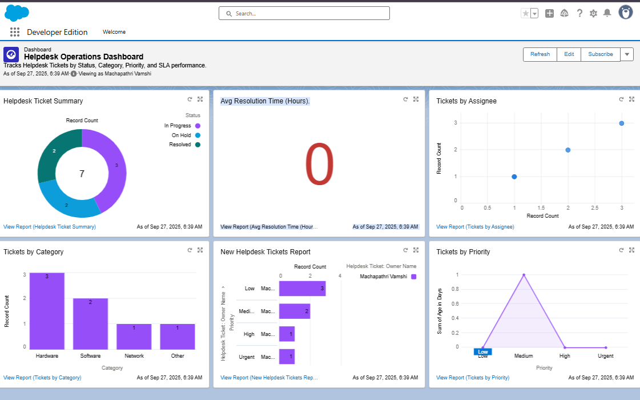  
PART F — Schedule Refresh  
- Dashboard → Subscribe → Daily 8 AM.  
- Reports → Subscribe → Daily 9 AM.

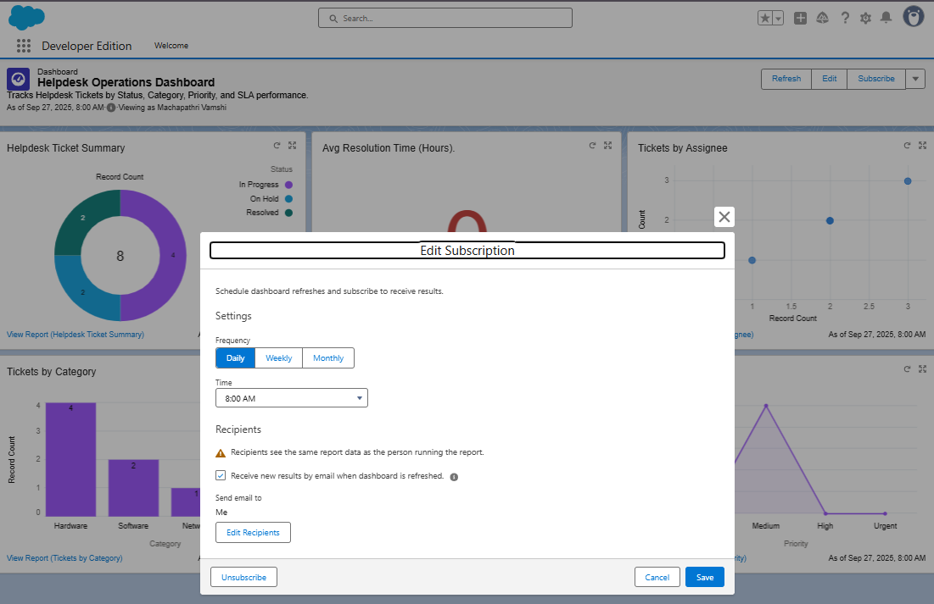

PART G — Sharing & Permissions  
- Share “Helpdesk Reports” and “Helpdesk Dashboards” folders with IT Support Group.  
.  
FINAL CHECKLIST  
✓ Created Resolved\_Date\_\_c (Date/Time)  
✓ Created Resolution\_Time\_Hours\_\_c (Formula)  
✓ Created Age\_in\_Days\_\_c (Formula)  
✓ Flow activated  
✓ Reports & Dashboards created  
✓ Dashboard filters added  
✓ Dashboard scheduled  
✓ Tests verified

# ****Phase 10 – Quality Assurance Documentation****

## ****Helpdesk Ticket Assignment Flow****

### ****USE CASE / SCENARIO****

When a new **Helpdesk Ticket** record is created **without an Assigned Support Agent**, the system should automatically perform the following actions:

* Assign a default **IT Support User** or Queue.
* Send an **email notification** to the assigned support agent.
* Create a **follow-up Task** assigned to that support agent.

### ✅ ****TEST CASE 1: Auto-Assignment of IT Support Agent****

| **Field** | **Details** |
| --- | --- |
| **Use Case** | Automatically assign an IT Support agent when “Assigned To” field is left blank during ticket creation. |
| **Test Steps** | 1. Create a new Helpdesk Ticket. 2. Leave the “Assigned To” field blank. 3. Save the record to trigger the Flow. |
| **Expected Result** | The system should automatically assign the ticket to the default IT Support user or group. |
| **Actual Result** | The “Assigned To” field was automatically filled with the default IT Support user. |
| **status** | Passed |

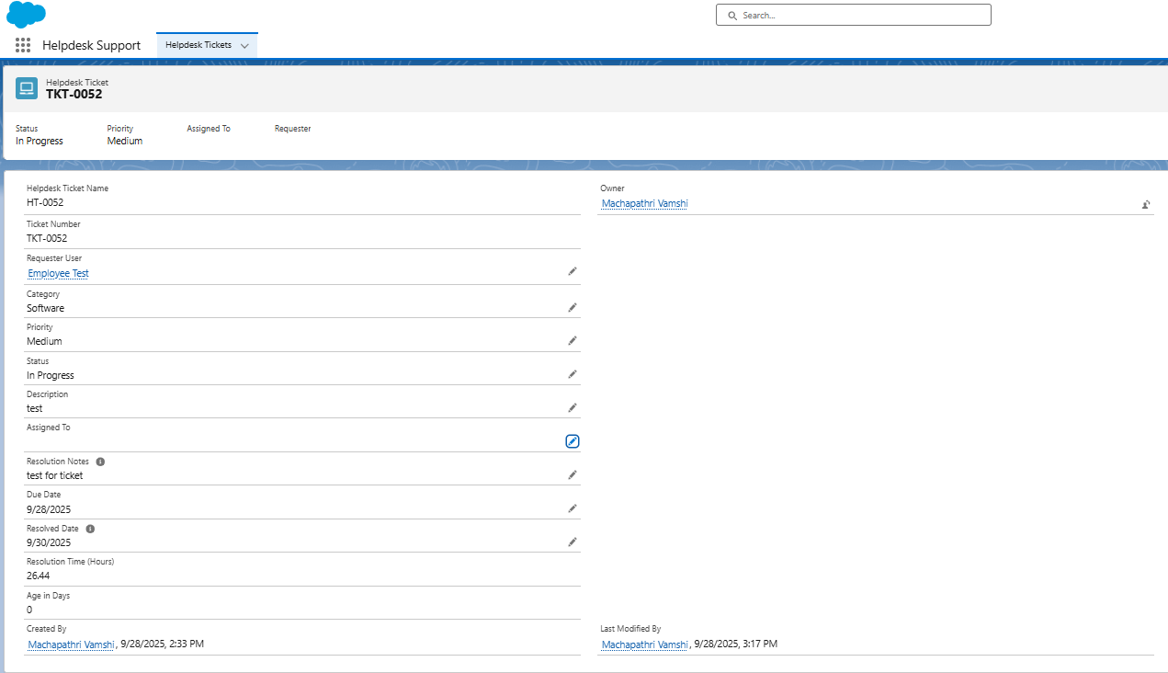

## ****TEST CASE 2: Invalid Test Case – Feedback Email Trigger****

| **Field** | **Details** |
| --- | --- |
| **Use Case** | Verify if a feedback email is sent to the requester when a ticket is resolved. |
| **Test Steps** | 1. Resolve a Helpdesk Ticket. 2. Check if a feedback or satisfaction survey email is sent automatically. |
| **Expected Result** | System should send a feedback email to requester. |
| **Actual Result** | No email sent — feature not implemented in current phase. |
| **Root Cause** | Feedback email flow not developed; marked as **future enhancement**. |
| **Resolution** | This test case is marked **“Not Valid”** for current release (Phase 10). To be implemented in future phase if client requests feedback automation. |
| **Status** | ❌ Not Valid / Out of Scope |

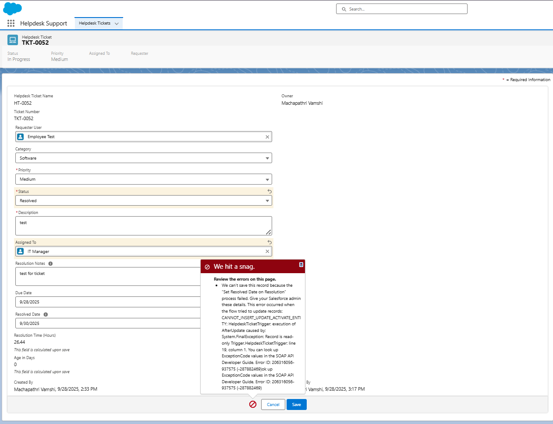

### ****TEST CASE 3: Invalid Test Case – Resolution Notes Missing****

| **Field** | **Details** |
| --- | --- |
| **Use Case** | Verify system behavior when a Helpdesk Ticket is marked as "Resolved" without entering Resolution Notes. |
| **Test Steps** | 1. Open an existing Helpdesk Ticket. 2. Change the Status field to "Resolved" without filling in the Resolution Notes. 3. Click Save. |
| **Expected Result** | System should restrict saving and display a validation error message — “Please enter Resolution Notes before resolving the ticket.” |
| **Actual Result** | Ticket was saved without Resolution Notes — no validation or warning displayed. |
| **Root Cause** | Validation rule for mandatory Resolution Notes on Resolved status not configured or inactive. |
| **Resolution** | Create a **Validation Rule** on Helpdesk Ticket: AND(ISPICKVAL(Status\_\_c, "Resolved"), ISBLANK(Resolution\_Notes\_\_c)) to ensure users cannot resolve tickets without entering notes. |
| **Status** | ⚠️ **Failed** – Requires Fix in next update |

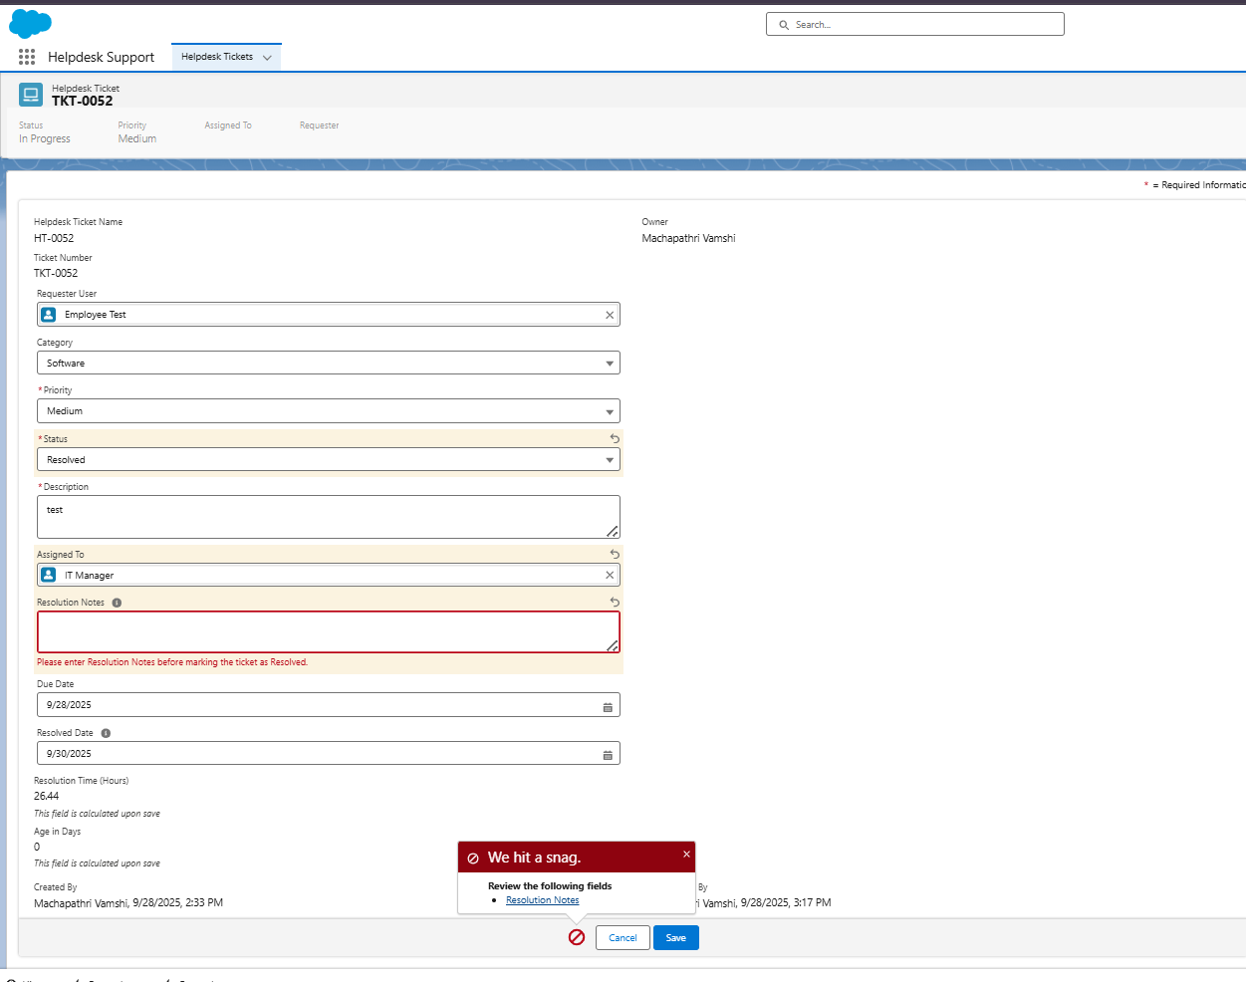

# **Benefits of the Helpdesk Ticketing System:**

1. **Saves time:** Many routine tasks like ticket assignment and notifications happen automatically, so support teams can focus on solving problems.
2. **Gives clear visibility:** Dashboards and reports make it easy to track ticket progress, spot delays, and measure team performance.
3. **Makes teamwork easier:** Everyone works on the same platform, so employees, support staff, and managers stay on the same page.
4. **Keeps data safe:** Profiles and permissions make sure only the right people can see or edit information.
5. **Grows with the company:** The system is built on Salesforce, so it can easily scale as more users and tickets come in.
6. **Works with other tools:** By connecting to external services, the system can integrate with third-party apps when needed.
7. **Easy to use:** With Lightning pages and a simple interface, employees can log and track tickets without confusion.
8. **Ready for the future:** The system can be expanded with AI, chatbots, or analytics to make support even smarter.

## Wrap-Up Summary:

In this final phase, I successfully presented and showcased my Salesforce CRM project — demonstrating **Admin Configuration, Automation, Apex Development, Reporting, and Security**.

The **Helpdesk Ticket Management System** improves IT issue resolution, enforces approval workflows, and ensures secure role-based access for every user.

🎓 This project helped me understand real-world Salesforce application design — from idea to deployment.

# Conclusion:

This project showed just how powerful Salesforce can be when it comes to solving real business problems. Our Helpdesk Ticketing System makes it easy for employees to log issues, keeps everything organized, and speeds up the resolution process with automation and smart workflows. We used Apex code, triggers, and even connected an external service to make the system more capable and scalable. The dashboards and Lightning components we built give users a clear, simple way to see what’s happening in real time. Best of all, this system is designed to grow — we could easily add features like AI-based ticket routing or chatbot support in the future. Overall, this project turned out to be a practical, efficient, and future-ready solution that shows the real value of Salesforce.

\*\*\*\*\* Thank you to my mentors, college, and evaluators for their support.\*\*\*\*\*

✨ **End of Phase 10 Document – Machapathri Vamshi** ✨